Ethiopia Voluntary Carbon Market Design

November 2019

Design of Ethiopia’s voluntary carbon offset scheme to support composting and urban afforestation activities

Contents

1 Introduction 5

1.1 Carbon Market Scenario in Africa 6

1.2 Non-African Voluntary Carbon Market Case Studies 7

1.3 Ethiopia and Carbon Markets 8

1.4 Conclusion 9

2 Market Components 10

2.1 Market Scope 10

2.2 Sectoral Scope 10

2.3 Market Size 11

2.4 Market Composition 11

2.5 Ethiopia’s Current Climate Institutional Framework 13

2.6 Bi/Multilateral Agencies Currently Involved in Ethiopia 16

2.7 Policy and Regulatory Support for Carbon Markets 17

2.7.1 Environment Policy of Ethiopia 17

2.7.2 Definition of Powers and Duties of the Executive Organs of the Federal Democratic Republic of Ethiopia Proclamation (No. 916/2015): 17

2.7.3 Ethiopia’s Climate-resilient Green Economy Strategy: 18

2.7.4 Kyoto Protocol Ratification Proclamation (No. 439/2005): 18

2.7.5 Paris Agreement Ratification Proclamation (No. 993/2017): 19

2.7.6 Solid Waste Management Proclamation (No. 513/2007): 19

2.7.7 Forest Development, Conservation and Utilization Proclamation (No. 1065/2018): 19

2.7.8 Directive on issuing “professional competence certificate to consultants and firms providing services in Environmental Impact Assessment, Environmental Audit and Climate Change fields” 22

2.7.9 Observations 22

3 Market Structure 24

3.1 Proposed Market Administrative Framework 24

4 Market Design 29

4.1 Market Workflow 29

4.1.1 Registration and Approval of Projects 29

4.1.2 Issuance of Verified Credits 30

4.1.3 Purchase and Retirement of Ethiopian Carbon Credits (ECC) 32

4.2 Credit Trading Cycle 35

4.3 Financial Framework 36

4.4 Secretariat’s Operational Framework 37

4.4.1 Executive Committee 37

4.4.2 Technical Officer(s) 38

4.4.3 Monitoring and Evaluation Officer(s) 38

4.4.4 Information and Communication Officer(s) 38

4.4.5 Administration Officer(s) 39

4.4.6 Finance Officer(s) 39

4.5 Integrating the Operational Framework into EFCCC Structure 39

4.5.1 Executive Committee 39

4.5.2 Technical Officer 40

4.5.3 Monitoring and Evaluation Officer 40

4.5.4 Information and Communication Officer 41

4.5.5 Administration Officer 41

4.5.6 Finance Officer 41

4.6 Monitoring, Reporting and Verification of Market 42

4.6.1 Monitoring 42

4.6.2 Reporting 51

4.6.3 Verification 51

4.7 Verification and Accreditation Process 52

4.8 ECC Pricing 53

5 Annexure I: African Case Studies 56

6 Annexure II: Global Case Studies 58

7 Annexure III: Sectoral GHG Accounting Methodologies 67

7.1.1 Measuring GHG Emission Reductions from Composting Activities 67

7.1.2 Measuring GHG Emission Reductions from Fertilizer Replacement 68

7.1.3 Measuring GHG Emission Reductions from Urban and Peri-urban Reforestation of Degraded Land 68

7.1.4 Measuring GHG Emission Reductions from Other Sectors 68

List of Figures

Figure 1: Types of actors and transactions in the carbon markets 5

Figure 2: Overview of coverage of the programs, by project type, sector and scope 7

Figure 3: Policies and proclamations supporting carbon markets in Ethiopia 17

Figure 4: Proposed administrative framework for Ethiopia’s carbon market 24

Figure 5: Market process 29

Figure 6: Key activities under registration and approval of projects 29

Figure 7: Key activities under issuance of verified credits 31

Figure 8: Key activities under purchase and retirement of credits 33

Figure 9: Credit trading cycle 35

Figure 10: Financial flow between market participants 36

Figure 11: Operational framework 37

Figure 12: Verification process 52

Figure 13: Credit price across regions 53

Figure 14: Credit price across sectors 54

Figure 15: Snapshot of Composting MRV Tool 67

List of Tables

Table 1: Emission reduction potential 11

Table 2: Potential sellers of credits 11

Table 3: Potential buyers in the project cities 12

Table 4: Roles and responsibilities of key stakeholders 13

Table 5: Key regulatory elements relevant for market design 22

Table 6: Key indicators to be monitored 42

Table 7: Credit price across standards 54

# Introduction

Carbon markets facilitate the trading of carbon credits and the commodity that is traded is measured in terms of ‘tonnes of carbon dioxide equivalent’ (tCO2e). There are two types of carbon markets —Regulated Carbon Market and Voluntary Carbon Market.

In a regulated carbon market, companies, governments, or other entities buy carbon offsets in order to comply with the limit/cap on the total amount of greenhouse gases (GHG) that they are allowed to emit within a cap-and-trade[1] system. Examples of regulated carbon markets are the European Union Emissions Trading System (EU-ETS), the California Emissions Trading System, the Australia Emissions Trading System, the British Columbia Emissions Trading System, and the New Zealand Emissions Trading System.

In a voluntary carbon market, there is no target/cap that a company, government or other entity has to comply with. Credits that originate from the voluntary carbon market are called Voluntary Emissions Reductions (VERs). VERs are bought by companies that want to voluntarily offset emissions generated via various business activities, and to market their brand as a socially responsible and green business.

There exist common players in the two markets namely, End users/buyers, Suppliers/Originators and Intermediaries.

**End users/buyers:** This includes individual or businesses that need credits to offset emissions for regulatory or voluntary purposes.

**Suppliers/originators:** It comprises any individual, business or a particular entity that sells credits after mitigating its own emissions.

**Intermediaries:** They intervene between originators and end users and has technical expertise and is familiar with a country context. Intermediaries include carbon funds and facilities, traders, brokers, aggregators, and exchanges.

Transactions can take place directly between suppliers and end users or via intermediaries.

Figure 1: Types of actors and transactions in the carbon markets

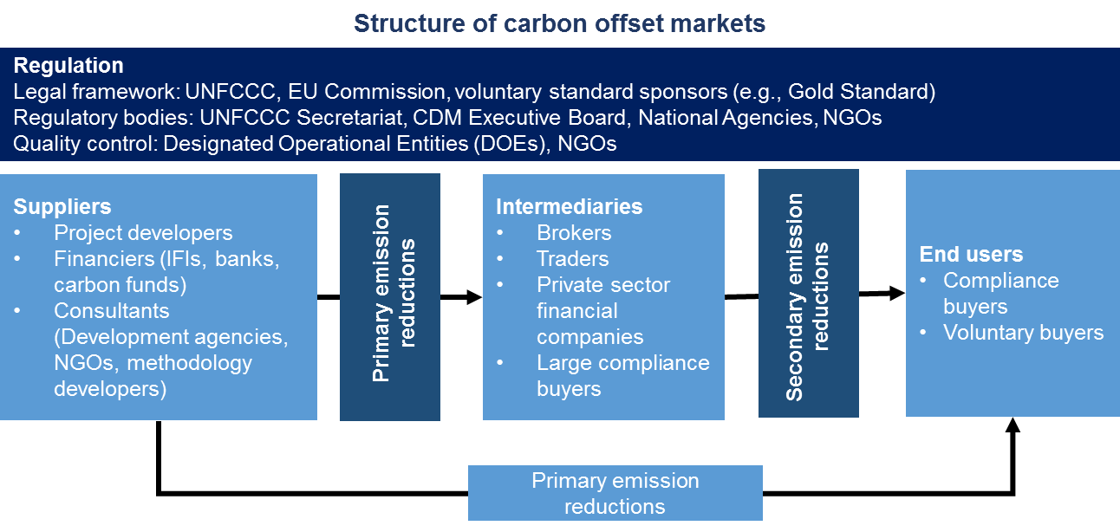

*Source: Adapted from ‘What are carbon markets?’, The Overseas Development Institute (ODI) publication*

According to the 2018 Voluntary Carbon Markets report, among the 2,008 global projects that have been issued with offsets, Asia accounted for ~51 percent; US and Canada combined accounted ~18 percent; Latin America and the Caribbean (~11 Percent); Europe (~11 percent); and Africa (11 percent)[2],[3]. The demand for voluntary credits is primarily driven by the purchase of VERs, particularly by companies that want to position themselves as green and environmentally conscious entities.

## Carbon Market Scenario in Africa

The African continent is endowed with abundant natural/renewable resources, which offers businesses the opportunity to establish clean energy projects in the country. Moreover, investors these days are interested in supporting projects that help reduce GHG emissions; which would further allow project developers to register their projects in existing or newly established local or global registries. A few examples on global registries are Verified Carbon Standard registry (Annexure II), American Carbon Registry and Markit Environmental Registry.

The countries in Africa have minimally participated in both the key carbon markets i.e., the regulated and voluntary carbon markets.

The penetration of carbon projects in Africa is low owing to the poor inflow of carbon finance in the country. Of the total global climate funds to combat climate change, less than 10 percent comes to Africa. The continent’s share of Clean Development Mechanism (CDM) projects remains low, at less than 3 percent of the total projects that were registered under the CDM, compared to over 60 percent in China[4].

CDM has inherent challenges such as unequal regional distribution of projects, lack of concern about environmental integrity, technology transfer and complex governance procedures. Additionally, factors that influence the price of CERs such as lengthy duration for verifying methodology and validating CER issuances are among the key barriers to a new entrant in the CDM market. These aspects have contributed significantly to the lack of uptake of CDM in Africa.

Owing to the stringent nature of rules under CDM, most project developers in Africa are interested in the sale of credits in voluntary carbon markets. However, Africa’s share of voluntary carbon market is still low and accounts for just 1 percent compared to the rest of the world because of the existing challenges in developing a market in the continent.

Some of the key challenges include lack of coordination between the institutions involved, challenges around regulations and policy; inadequate capacity to deal with technical and procedural challenges. Other challenges include trade frauds and accounting discrepancies arising from a weak regulatory framework. Furthermore, ease of doing business in Africa is relatively low. While companies from developed countries have been setting up their businesses in Africa, the existing legal and institutional framework is quite weak. The barriers to trade and investment further inhibits access to new technologies and therefore hinders the timelines to meet the targeted emission reductions from a project.

While these challenges exist, a few African countries, including Kenya, Ghana, Mozambique, Uganda and the Democratic Republic of Congo started witnessing an increase in the demand for projects in the voluntary carbon markets, including projects in sectors such as energy, forestry, agriculture and waste. The outlook for the market is expected to be positive, owing to various initiatives that boost clean development. This further, attract the attention of investors. For instance, the Center for Disease Control (CDC) Climate partnered with the West African Development Bank (WADB) and the French Development Agency (AFD) in 2016 to launch a Carbon Fund that is dedicated to Africa. This included a funding support of EUR45 million to develop a mechanism that assist operators with technical aspects of setting up their projects.

A few bilateral funding mechanisms have also been supporting the growth of carbon markets in Africa. For instance, Swedish Energy Agency’s ‘Institutional Support for Capacity Building Programme for CDM offered support for capacity building to the potential project owners, financial and legal institutions and governmental agencies in Kenya, Tanzania and Uganda. In addition, it has also supported the creation of CDM projects, which the Swedish government used to offset its emissions[5].

These initiatives and support for building capacities is expected to increase traction in Africa’s carbon market that further has the potential to generate carbon credits.

The case examples that provide an existing scenario of a carbon market in Africa, particularly in the waste and forestry sectors are added in Annexure 1.

## Non-African Voluntary Carbon Market Case Studies

The voluntary carbon projects exist in 83 countries globally and are traded freely between buyers and sellers in different countries. Some countries, like the UK and South Korea, have government-operated domestic markets where businesses and individuals can buy offsets produced within the country. There are about 2,008 projects that have been issued offsets during 2008–18, particularly in Asia (51 percent) and North America (18 percent). About 11 percent of projects are based in Latin America and the Caribbean, 11 percent in Europe, and 11 percent in Africa[6].

The summary of various programs across the world via which the buyers are issued with voluntary credits has been provided in the figure below, which include various sectors covered. Some of them are Australia’s Carbon Farming Initiative (AU CFI), Clean Development Mechanism (CDM), Joint Implementation (JI) Track 1, California Compliance Offset Program (CA COP), Chinese CER (CCER), and Switzerland’s Offset Program (CH OP). Some of them are Australia’s Carbon Farming Initiative (AU CFI), Clean Development Mechanism (CDM), Joint Implementation (JI) Track 1, California Compliance Offset Program (CA COP), Chinese CER (CCER), and Switzerland’s Offset Program (CH OP).

Figure 2: Overview of coverage of the programs, by project type, sector and scope[7]

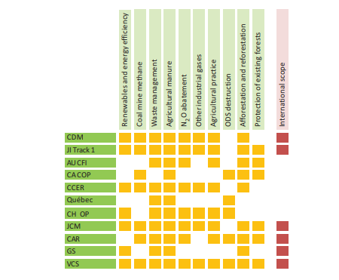

*Note: AU CFI = Australia’s Carbon Farming Initiative; CA COP = California’s Compliance Offset Program; CAR = Climate Action Reserve; CCER = China CER; CDM = Clean Development Mechanism; CH OP = Switzerland’s Offset Program; GS = Gold Standard; JCM = Joint Crediting Mechanism; JI = Joint Implementation; Québec = Québec’s Offset Program; VCS = Verified Carbon Standard.*

Following are the key primary users of credits in the programs/schemes mentioned in the figure above:

* Clean Development Mechanism (CDM) and Joint Implementation (JI) Track 1: Voluntary buyers, private buyers that are covered under an ETS (e.g., EU-ETS), and Annex A countries that have a reduction commitment under the Kyoto Protocol
* Australia’s Carbon Farming Initiative (AU CFI): Voluntary buyers and the Australian Government
* California Compliance Offset Program (CA COP): Voluntary buyers and Entities covered by California’s and the Quebec’s Cap-and-Trade programs
* Chinese CER (CCER): Voluntary buyers (both Chinese and international) and compliance buyers from Chinese pilot ETS
* Québec’s Regulation respecting a Cap-and-Trade System for GHG Allowances (Québec): Voluntary buyers and Entities covered by the Québec ETS and the California ETS
* Switzerland’s Offset Program (CH OP): Producers and importers of motor fuels, and fossil-thermal power plant operators
* Japan’s Joint Crediting Mechanism (JCM): Both government and private sector can be financing entities; and allocated units
* The Climate Action Reserve (CAR)[8]: Voluntary buyers in the US
* Gold Standard: Voluntary buyers; private buyers that are covered under an ETS (e.g. EU-ETS)
* Verified Carbon Standard: Voluntary buyers particularly in the US and Europe

The key global case examples for voluntary carbon markets in Sri Lanka, China and New Zealand have been detailed that provide analysis on governing institutions and their responsibilities, projects covered and emission reductions in annexure 2.

## Ethiopia and Carbon Markets

Ethiopia’s existing carbon market experience comes largely from its participation in global market-based instruments, particularly the CDM. In this regard, the country has the highest technical potential among other low developing countries to develop CDM projects (estimated at 32 million Certified Emission Reductions annually)[9].

Furthermore, the government of Ethiopia supports numerous policies for projects that help reduce GHG emissions. Under the Ministry of Finance (MoF), a Climate Resilient Green Economy (CRGE) facility has been established to support projects in climate change.

The country aims to develop an institutional framework for a carbon market, which comprises participation from both the public and private sectors. This market is expected to facilitate the transfer of carbon credits from project developers to buyers, who are interested in offsetting their emissions in sectors such as afforestation and composting.

## Conclusion

The case examples studied describe the key components that contribute towards the success of a voluntary carbon market which consist of the following:

* Large emission reduction potential in various sectors for emission trading
* Strong institutional base having adequate technical expertise for implementing the various market interactions
* Strong policy framework supporting the market development and implementation
* Private sector interest and participation
* A carbon registry to facilitate the exchange of carbon credits

The status of these components in Ethiopia has been studied in detail in chapter 2, the analysis from which has been utilized in the subsequent chapters 3 and 4.

# Market Components

This section details the current status of key components in Ethiopia that will contribute towards development and implementation of Ethiopia’s voluntary carbon market.

## Market Scope

Ethiopia’s voluntary carbon market has been designed for facilitating trading of emission reduction units called the ‘Ethiopian Carbon Credit (ECC)’ between project developers (sellers) and buyers. The project developers are currently envisaged to be city administrations from the six project cities under the COMPOST NAMA programme, which are Adama, Bahir Dar, Bishoftu, Dire Dawa, Hawassa and Mekelle implementing mitigation projects. However, the market scope is not limited to the six cities and allows for participation of any small/ large public and private sector companies implementing mitigation reduction projects. Buyers could be any small/ large public and/or private sector companies operating within Ethiopia or multi/bi-lateral agencies.

The market will include credits generated from reduction of any of the six GHGs, which are carbon dioxide (CO2), methane (CH4), nitrous oxide (N2O), ozone (O3), chlorofluorocarbons (CFCs), and hydrofluorocarbon (HCFCs and HFCs).

## Sectoral Scope

The sectoral scope defined for the market currently includes projects under the following categories as defined under the COMPOST NAMA:

* Waste handling and disposal
* Afforestation and reforestation

While at the outset the market will focus on composting and afforestation projects (as defined under the COMPOST NAMA), following successful deployment and implementation of the market in Ethiopia it can be further expanded to include projects from a wider gamut of sectors as shown below, increasing the credit generation potential of the market:

* Agriculture
* Energy (renewable/ non-renewable)
* Energy distribution
* Energy demand
* Manufacturing industries
* Chemical industries
* Construction
* Transport
* Mining/Mineral production
* Metal production
* Fugitive emissions from fuels (solid, oil and gas)
* Fugitive emissions from production and consumption of halocarbons and sulphur hexafluoride
* Solvents use

The internationally defined methodologies that can be used for estimation of emissions reductions under each scope have been highlighted in Annexure III.

## Market Size

The potential market size, which is potential carbon credits generated in Ethiopia, has been assessed based on emission reductions from the existing and planned waste management and afforestation initiatives undertaken by the city administrations under the COMPOST NAMA programme.

The estimated offsets in the next 10 years from the waste and forestry activities under COMPOST NAMA programme are provided in table 1. The offset potential may change in the future with any change in the current and/or planned activities such as expansion of existing projects and/or addition of new projects. Changes in various elements such as population, economic growth, policy and regulatory frameworks, etc. the offset generation potential and corresponding market circumstances could change in the future.

Table 1: Emission reduction potential

| **City** | **Emission Reduction Units\*** | |
| --- | --- | --- |
| **Waste Management** | **Afforestation** |
| Adama | 43,772 | 288,015 |
| Bahir Dar | 82,662 | 691,765 |
| Bishoftu | 10,607 | 242,520 |
| Dire Dawa | 21,010 | 508,888 |
| Hawassa | 33,033 | 304,152 |
| Mekelle | 86,343 | 209,760 |
| **Total** | **277,427** | **2,245,100** |
| **2,522,527** | |

*1 tCO2e equals 1 Emission Reduction Unit

However, the market, as previously mentioned, is not limited to the above-mentioned projects and is flexible to include projects from other sectors such as transport, energy, buildings, etc. as well as projects implemented by public and private players from other cities.

## Market Composition

Ethiopia’s voluntary carbon market comprises various public and private entities as sellers and buyers of verified credits.

The sellers in the market are primarily entities responsible for developing, managing and/or implementing any project in the waste management and afforestation sector that leads to reduction or removal of GHG emissions. Sellers can be any one entity, either public or private, or an association of 2 or more entities responsible for carrying out various project activities. The identified potential sellers are as follows:

Table 2: Potential sellers of credits

| **Sellers** | **Current Role** |
| --- | --- |
| City Administrations | The city administration is responsible for overall waste management in the city, which includes collection, transportation, disposal and processing of all types of waste generated in urban areas.  The city administration is also responsible for urban greenery activities such as tree plantation and identifying and providing land for plantation activities. |
| MSEs | The MSEs support the city administration in waste collection, transportation and disposal at landfill sites. |
| Associations/ Private Operators | The associations/ private operators support the city administration in waste collection, transportation and disposal at landfill sites. |
| State Forest Developers | The state forest developers are responsible for demarcating the forest land as productive, protected and preserved. They are also responsible transferring the ownership of land to private, community and association forest developers. |
| Private Forest Developers | The private forest developers are involved in various forest development and management activities. |
| Community Forest Developers | The community forest developers are involved in various forest development and management activities. |

The potential buyers in the market are small and large entities operating within the country. These companies could be private enterprises (such as East Africa Bottling (coca cola) and Pepsi), public and government enterprises (such as Ethiopian Airlines), and endowments (such as Mesfin Industrial Engineering and Dashin Brewery). These companies, especially the ones having large operational footprint within and outside of Ethiopia, have voluntary internal targets to reduce their GHG footprint through abatement and offset strategies as part of their CSR initiatives. The identified potential buyers within Ethiopia are as follows:

Table 3: Potential buyers in the project cities

| **City/ Region** | **Potential Buyers\*** |
| --- | --- |
| Adama | TM Food Complex |
| East Africa Industry (Tea) |
| Nazehrete Plastic |
| Adefris Kifle Plastic |
| Tekelu Maru PP & Plastic |
| Ahwan Plastic |
| Red Fox (Koka Cement) PLC |
| Bahir Dar | Kulbi Gebreal Food Complex |
| East Africa Bottling (Coca Cola) Soft Drinks |
| Bishoftu | Hora Tannery |
| Hore Tekome Plastic |
| Blunile Pp and Craft Paper Bag |
| Dire Dawa | East Africa Bottling (Coca Cola) Soft Drinks |
| Aqua Dire Mineral Water |
| Dire Dawa Cement Factory |
| Hawassa | ETAB Soap and Detergent Industry |
| BGI Hawassa Brewery Industry |
| Millennium Soft Drink Industry |
| Hawassa Textile Industry |
| Mekelle | Adolis Plastic and Shoe Factory |
| Kadisco Plastic and Shoe Factory |
| Beruhtesfa Plastic Factory |
| Other public and private players such as Ethiopian airlines, Total Ethiopia, BGI Breweries, Heineken Breweries, Coca Cola, and H&M having a large operational footprint in the country having global emission reduction targets are the key stakeholders in the market. | |

The bi/multi-lateral agencies active in Ethiopia could also be explored as potential buyers of the credits generated. For example, the World Bank purchased 73,000 credits from the Humbo project, which is Africa’s first carbon trading forestry project.

## Ethiopia’s Current Climate Institutional Framework

There are various government and non-government agencies in Ethiopia that are important stakeholders for the development and operation of a carbon market. The table below highlights the key stakeholders relevant for the development of the market and their roles and responsibilities in the country:

Table 4: Roles and responsibilities of key stakeholders

| **Stakeholders** | **Roles & Responsibilities** |
| --- | --- |
| **Environment, Forest, Climate Change Commission (EFCCC)** | EFCCC houses the GEF Operational Focal Point, the UNFCCC Focal Point and the REDD+ Focal Point. EFCCC provides technical guidance on how to support solid waste management (based on its involvement in the SWM Proclamation) and urban greenery (due to its extensive experience in Addis Ababa). The Commission’s Forest Department experts will support the reforestation efforts to be undertaken in each of the 6 cities and towns.  Additionally, EFCCC has been involved in linking the project MRV mechanism with the national MRV system that is expected to be designed during the project lifetime.  EFCCC has extensive experience in carbon markets through participating in CDM and REDD+ activities and will be closely be involved in the design and operation of the national voluntary carbon offset scheme. |
| **Ministry of Urban Development and Construction (MUDC)** | The MUDC is the principal federal government entity responsible for afforestation and waste management activities providing coordinated support to urban centres to make them capable of influencing their surroundings in implementing these initiatives. MUDC is the lead implementing body for the government’s national initiative on Green Infrastructure. Urban Climate Resilience Bureau manages urban waste and greenery initiatives. It also oversees land-cover and housing projects and is active in supervising MSE activities.  In addition, the Urban Climate Resilience Bureau of the MUDC is responsible for overall project coordination – i.e. for sharing project reports, involve stakeholders to contribute at different stage of the project implementation, and to collaborate with stakeholders to find alternatives solutions if and when problems arise. It will also coordinate with government ministries and stakeholders in waste management and afforestation activities; and liaise with donors and potential participants in the voluntary carbon offset market. The MUDC will play a catalytic role in the implementation of the national voluntary carbon offset scheme through the provision of cash co-financing to operationalise it.  MUDC will assure the social and environmental safeguards of the project are implemented in the intervention cities.  Ministry of Urban Development and Construction (MUDC) is currently responsible for the following:   * Follow up the activities of city administrations accountable to the Federal Government * Provide support for plan-led urbanization and follow-up its implementation * Establish integrated national urban system by preparing national spatial plan and follow up implementation of the same and also provide capacity building support to regional governments |
| **Ministry of Finance (MoF)** | The Government of the Federal Democratic Republic of Ethiopia launched a CRGE strategy in 2011 that aims to build a carbon neutral and climate resilient middle-income economy by 2025. It also aims to reduce the national greenhouse gas emission by 2030 by focusing on four key sectors — Agriculture, Forestry, Power and Transport.  In this regard, the MoF oversees the Climate Resilient Green Economy (CRGE) Facility. The Facility has been established in order to channel international financing for the implementation of Ethiopia’s Green Economy Strategy. Accordingly, MoF in collaboration with the **Environment, Forest and Climate Change Commission (EFCCC)** established (in 2012) and operationalized (in 2013) the **CRGE facility** to attract climate finance to support the institutional building and implementation of Ethiopia’s CRGE Strategy. The facility is governed by a management committee, which is co-chaired by the MoF and EFCCC state ministers. The CRGE facility has accomplished the following key tasks in Ethiopia:   * Set up the financial and program management; environment and social safeguards systems and Monitoring and Evaluation (M&E) framework that are required by international climate funds as part of their due diligence processes * Developed a registry * Mobilized an additional US$80 million for REDD+ Investment Plan * Conducted a national CRGE capacity assessment and prepared a CRGE Capacity Development Framework Road Map to strengthen government capacities to operationalize the CRGE strategy, plan, mobilize resource and deliver green, climate resilient development results * Developed a private sector engagement strategy   MoF oversees project budget utilisation, integrating the MUDC MRV mechanism with that of the CRGE facility through EFCCC. It will also be involved in the project phase-out period to assure sustainability of the NAMA project with MUDC’s day-to-day operations. |
| **Ministry of Agriculture and Natural Resources (MoANR)** | The Ministry of Agriculture provides technical guidance on sustainable urban agriculture and composting. The NAMA project collaborates with the Ministry’s Agricultural Transformation Agency during composting quality testing.  The MoANR is also responsible for developing work owner/process for urban agriculture, investigating the soil condition of the urban area where horticultural products could be produced, promoting and creating market opportunities to sell the products; and providing extension services on composting.  The project will link with MoANR under the Soil Fertility Department for wider dissemination of quality compost into urban and peri-urban agriculture. The MoANR will also be involved in establishing field trials on the use of compost in urban agriculture, and in the dissemination of the results to farmers. Its agricultural extension services will act as an outlet for marketing of compost in urban agriculture. |
| **Regional Bureaus for Urban Development** | Regional Bureaus for Urban Development and Land Use are the lead implementing bodies for the Government at the regional level with regards to urban planning, sanitation, beautification and land use. The Regional Bureaus have direct oversight of the municipal waste management and afforestation activities in terms of budgetary provisions and monitoring and evaluation of performance. The bureaus will cascade developed standards, manuals, maps, guideline in the respective cities and towns. |
| **The 6 urban cities – City Administrations/ Municipalities** | The 6 cities and towns are the main beneficiaries of the COMPOST project. For instance, about 62% of the total GEF funding – will take place in the urban cities and towns. The municipalities of Adama, Bahir Dar, Bishoftu, Dire Dawa, Hawassa and Mekelle will be implementing waste management and afforestation initiatives. These municipalities will directly recruit MSEs to implement streamlined waste collection services, rearing of seedlings in nursery operations, and the plantation of seedlings for urban green shrubbery and trees in public areas.  Further, each one of the 6 cities and town will integrate project activities with regional universities to undertake R&D, capacity building and information sharing. These universities are: Adama University for the City of Adama and Bishoftu town; Wondogenet University for the City of Hawassa; Haramaya University and Diredawa Universiy for the City of Dire Dawa; Mekmelle University for Mekelle City and Bahir Dar University for Bahir Dar City.  The cities and towns will also be responsible for selecting and providing incentives for source sorting of household waste; providing or facilitating the provision of licences to MSEs engaged in composting and afforestation activities; and awareness creation at household level regarding waste management, among others.  A critical intervention of the cities and towns concerns the mapping and development of Resettlement Action Plans (RAPs) relating to illegal settlers on land forming part of the project boundary for afforestation activities, as per the Social and Environmental Screening. |

## Bi/Multilateral Agencies Currently Involved in Ethiopia

**Partnerships of Ethiopian government with funding organizations and other governments to support the implementation of projects in Ethiopia:**

The Government of Ethiopia launched the Climate-Resilient Green Economy (CRGE) initiative to address the adverse impacts of climate change and build a green economy. In addition, it has been partnering with various institutions and governments for obtaining support that is required to boost the development of projects that aims to reduce carbon emissions in the country. A few examples of partnerships are mentioned below.

**Partnership with Norway and Sweden government (2015–19)**: This project is being executed by the Environment Forest and Climate Change Commission and aims at enhancing the institutional capacity of the forest sector; increase forest coverage to boost carbon sequestration and promote sustainable supply of wood and wood products. This budget required for the project is US$22.5 million, out of which US$10.6 million, US$6.4 million and US$1.3 million has been secured by the Norwegian government; Swedish government and Ethiopian government (in-kind contributions provided by CRGE facility), respectively[10],[11].

**Partnership with Department for International Development (DFID)**: The CGRE facility, under the Ministry of Finance (MoF) has partnered with UK-based DFID to provide US$20 million to support projects in sectors, including energy, agriculture, forestry and Transport.

**Partnership with Global Green Growth Institute (GGGI)**: The MoF and EFCCC partnered with GGGI to undertake need-based analytical work, including the CRGE financial need analysis, MRV, and job creation strategy formulation. GGGI has been working with the EFCCC, MoF, the Prime Minister’s Office, the Ministry of Water, Irrigation and Energy (MoWIE) and the Ministry of Agriculture and Natural Resources (MoANR) since 2013. In particular, GGGI provided support to develop core systems and processes, for example the Operations Manual of the CRGE Facility, and its monitoring and evaluation system[12].

**Partnership with UNDP**: UNDP is partnering with the MoF’ CRGE facility and EFCCC to support the implementation of CRGE and has deployed three senior advisors to the facility. UNDP has been financing the operation of the facility and providing support for analytical and project design initiatives[13].

**Partnership with Global Environment Facility (2016–2021)**: The Ministry of Urban Development and Construction (MUDC) in Ethiopia partnered with the Global Environment Facility for a project titled “Creating Opportunities for Municipalities to Produce and Operationalise Solid Waste Transformation (COMPOST)” for amount worth US$6.7 million. UNDP also provided partial support for amount worth US$250,000. The project aims to promote greater use of Integrated waste management and afforestation approaches in Ethiopian cities and towns. This will be achieved through development of a market-based mechanism in which micro and small enterprises (MSEs) are supported to ensure financial sustainability of compost production and utilization[14].

## Policy and Regulatory Support for Carbon Markets

There are policies and proclamations that directly or indirectly support the development and functioning of a carbon market. These linkages have been represented in the figure below and briefly detailed in the following sections.

Figure 3: Policies and proclamations supporting carbon markets in Ethiopia

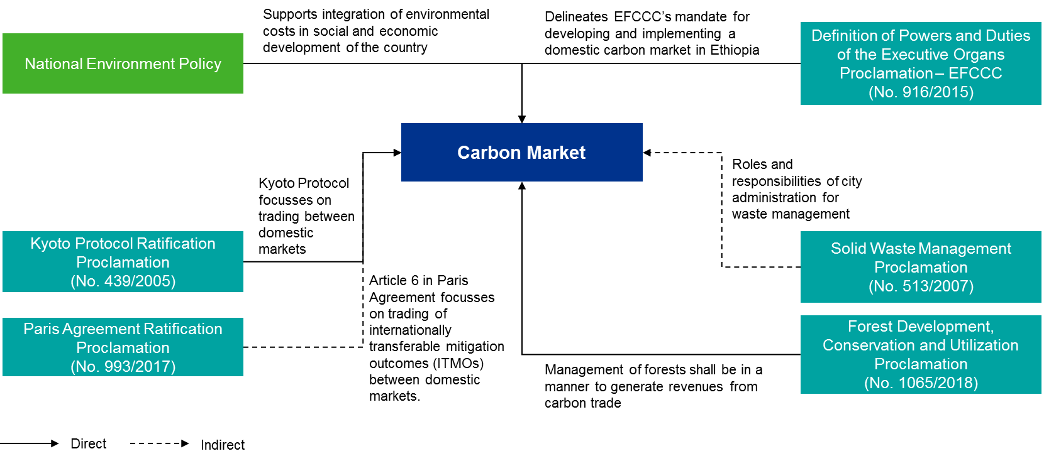

### Environment Policy of Ethiopia

The policy provides guidelines for the integration of environmental considerations and costs in the social and economic development of the country. The overall policy goal is to improve and enhance the health and quality of life of all Ethiopians and to promote sustainable social and economic development through the sound management of natural, human-made & cultural resources and the environment as a whole. The objective is to meet the demands of the present generation without adversely impacting the ability of the future generations to fulfill their own needs.

* With regards to atmospheric pollution and climate change it directs to recognize that even at an insignificant level of contribution to atmospheric greenhouse gases, a firm and visible commitment to the principle of containing climate change is essential and to take the appropriate control measures for a moral position from which to deal with the rest of the world in a struggle to bring about its containment by those countries which produce large quantities of greenhouse gases.
* Under the forest, woodland and tree resources section, the policy recognizes the roles of communities, private entrepreneurs and the state in forestry development. It also encourages their active participation in the development and management of forest resources. The policy focuses on the integration of forestry development strategies in other sectoral strategies.
* Under the human settlement, urban environment and environmental health section, the policy emphasizes on waste collection services, safe disposal of waste, and the creation of green spaces in urban areas, including community forests and woodlands for fuelwood and as a recreational amenity.

### Definition of Powers and Duties of the Executive Organs of the Federal Democratic Republic of Ethiopia Proclamation (No. 916/2015):

The powers and duties defined for the Ministry of Environment, Forest and Climate Change (now Environment, Forest and Climate Change Commission (EFCCC)) that support development and functioning of carbon markets are as follows:

* Coordinate activities to ensure that the environmental objectives provided under the Constitution and the basic principles set out in the Environmental Policy of the Country are realized
* Prepare a mechanism that promotes social, economic and environmental justice and channel the major part of the benefit derived thereof to the affected communities to reduce greenhouse gases emissions that would otherwise have resulted from deforestation and forest degradation
* Coordinate actions on obtaining the necessary resources for building a climate resilient green economy in all sectors and all regional levels and also provide capacity building support and advisory services
* Propose incentives or disincentives to discourage practices that may hamper the sustainable use of natural resources or the prevention of environmental degradation or pollution

### Ethiopia’s Climate-resilient Green Economy Strategy:

The Government is implementing a Climate-Resilient Green Economy (CRGE) initiative to protect the country from the adverse impacts of climate change and thus build a green economy to help realize its ambition of reaching middle-income status before 2025. The strategy is based on four pillars:

* Improving crop and livestock production practices for higher food security and farmer income while reducing emissions
* Protecting and re-establishing forests for their economic and ecosystem services and to restore their role as carbon stocks
* Increasing electricity generation from renewable sources for domestic and regional markets
* Adopting modern and energy-efficient technologies in transport, industrial sectors, and buildings

The government has set up a facility called the ‘CRGE Facility’ to mobilize domestic and international sources of finance for the implementation of the CRGE Strategy and to manage results-based payments generated from projects that reduce greenhouse gas emissions, including carbon credits generated from REDD+ projects. The CRGE Facility has been identified as the main government unit for marketing and selling carbon credits generated from national REDD+ projects.

The CRGE Facility is also expected to facilitate greater coordination amongst climate change activities, by providing a single engagement point where stakeholders can engage and make decisions about climate change issues, minimize duplication and increase overall effectiveness.

During the CRGE Facility's initial phase, the United Nations Development Programme will administer all international funds until the capacity of the Facility has been strengthened to manage the full CRGE account. MoF will administer all domestic funds of the Facility.

### Kyoto Protocol Ratification Proclamation (No. 439/2005):

The proclamation was issued in the year 2005 to implement the protocol to reduce GHG emissions. The proclamation has authorized the Environment Protection Authority (EPA) (now EFCCC) to implement this agreement in collaboration with the appropriate federal, regional, and city administration government organs.

### Paris Agreement Ratification Proclamation (No. 993/2017):

The proclamation was issued in the year 2017 to enhance implementation of various modalities of the Agreement in Ethiopia and to strengthen global response to the threat of climate change.

With regard to voluntary carbon markets, the Agreement in Article 6 details:

* Use of Internationally Transferred Mitigation Outcomes (ITMOs) for any carbon based trade between NDCs that might take place voluntarily or through a regulated market
* Creation of an Emissions Mitigation Mechanism (EMM) to contribute to the mitigation of greenhouse gas emissions to ensure overall reduction in global emissions while delivering sustainable development benefits.

The proclamation has authorized the EFCCC to implement this Agreement in collaboration with appropriate federal and regional government organ, city administrations, and international, national, and domestic institutions.

### Solid Waste Management Proclamation (No. 513/2007):

The solid waste management proclamation focusses on defining roles and responsibilities of urban administrations and waste generators. The key aspects of the solid waste management proclamation relevant to the designing of carbon market have been highlighted below:

|  |  |
| --- | --- |
| **Obligations of Urban Administration** | * Urban administrations shall create enabling conditions to promote investments in solid waste management services. * A person has to obtain a permit from the concerned body of an urban administration prior to his engagement in the collection, transportation and use of disposal of solid waste. |
| **Solid Waste Management Planning** | * Urban administrations shall set their own schedules and based on that prepare their solid waste management plan and report of implementation. * Urban administrations may transfer their responsibilities to the lowest administrative units. However, the plan and reports prepared by all lowest administration units shall be consolidated by the urban administration. |
| **Management of Households Waste** | * The head of each household shall ensure that recyclable solid wastes are segregated from those that are destined for final disposal and are taken to the collection site designated for such wastes. |
| **Construction of Solid Waste Disposal Sites** | * Each urban administration shall, in conformity with the relevant federal environmental standard, ensure that solid waste disposal sites are constructed and used properly. |

### Forest Development, Conservation and Utilization Proclamation (No. 1065/2018):

The forest development proclamation defines the rights, incentives and obligations of all types of forest developers. The key aspects of the proclamation relevant to the designing of carbon market have been highlighted below:

* **Private Forest Developer**

|  |  |
| --- | --- |
| **Rights** | * Acquire land that has been identified for forest development and to develop that forest * Generate forest products or provide services and conduct business by providing services * Benefit from carbon sales and eco-system services generated from the forest he develops, or which is under his possession |
| **Incentives** | * Exemption from land lease and any kind of tax for the first year of production * Access to loan upon fulfilling appropriate requirements |
| **Obligations** | * Provide the relevant authority with information about the forest * Fulfill and respect the required criteria of the transaction system in order to benefit from carbon and ecosystem services sales income |

* **Community Forest Developer**

|  |  |
| --- | --- |
| **Rights** | * Share benefits generated from the natural forests surrounding them without affecting their sustainable existence * Get priority, as appropriate, to benefit from the forest’s concession given by the government * Utilize, transact and add value to forest products in accordance with their management plan * Share any benefits generated from forest development as per the community by-laws |
| **Incentives** | * Exemption from any forest development income tax for the first two consecutive production years * Access to loan upon fulfilling appropriate requirements |
| **Obligations** | * Provide the relevant authority with information about the forest * Fulfill and respect the required criteria of the transaction system in order to benefit from carbon and ecosystem services sales income |

* **Association Forest Developer**

|  |  |
| --- | --- |
| **Rights** | * Register with the appropriate government body * Acquire land that has been identified for forest development and to develop that forest * Generate forest products or provide services and conduct business by providing services * Benefit from carbon sales and eco-system services generated from the forest he develops, or which is under his possession |
| **Incentives** | * Exemption from any kind of tax for the first production year * Access to loan upon fulfilling appropriate requirements |
| **Obligations** | * Provide the relevant authority with information about the forest * Fulfill and respect the required criteria of the transaction system in order to benefit from carbon and ecosystem services sales income * Educate and train their members to improve their knowledge and skills on forest development, protection and utilization in order to fulfill members’ social and economic responsibilities * The association shall pay income tax after two harvest periods |

* **State Forests**

The State forests have been classified as productive, protected and preserved

|  |  |
| --- | --- |
| **Responsibilities for productive forests** | * Regulate development, conservation and utilization of productive forests * Formulate forest development, conservation and utilization plans to allow the participation of local communities in the development and conservation of forests and benefit sharing |
| **Responsibilities for protected forests** | * Prepare and implement participatory forest management plans for forests * Planting of fast-growing species of trees along the periphery of the forests to demarcate the forest area to be used by the local community for firewood and construction |
| **Responsibilities for preserved forests** | * Demarcate and protect the forests * Protect forests from any human and domestic animals’ intervention except for the purposes of research, education, and disaster prevention |

* **Management of proceeds from productive and protected forests**
  + The forest shall be utilized in accordance with the management plan prepared and approved by the concerned authority.
  + The utilization of forests shall be undertaken by government organizations or by persons who are given concessions. The details shall be determined by the regulation in question.
  + The local community that resides inside or at the periphery of the forest may obtain the environmental, social and economic benefits depending on the local situation in line with the forest management plan upon obtaining permit from the concerned authority.
  + The management of the forest shall be in a manner to generate revenues from eco-tourism, carbon trade and other related eco-system services
* **Responsibilities of Government**
  + Government has to identify and register the state forest as either productive, protected or preserved
  + Government may demarcate a forest or forest land for the purpose of carbon trade
  + Both the above points shall be done through participation of the local community
  + Government shall formulate forest development, conservation and utilization plans to allow the participation of the local community in the development and conservation of forests and also in the sharing of benefits from the development of state forests.
  + Forests that are designated as protected or productive state forest may be given to the community, association or investors so that they conserve and utilize the former in accordance with the forest management plan and a directive is issued to this effect by the responsible body.
  + The government shall develop a system to ensure that those who benefit from the forest contribute to the development and conservation of forests.
  + For promoting the private and community forest development, government shall support, as may be necessary and provide incentives and tax exemption on imported tools and technologies used for the production of forest products and forest development.

### Directive on issuing “professional competence certificate to consultants and firms providing services in Environmental Impact Assessment, Environmental Audit and Climate Change fields”

The directive has been issued by EFCCC. The directive stipulates that EIA and environment audits should be conducted by professional consultants and firms that are registered and certified for their competence by the EFCCC. Environment audits prepared by unregistered and certified firms will not be eligible for review and approval. The regional EPFCCs have also started applying the stated directive of EFCCC. Furthermore, Directive No.2/2014 is among the guidelines put under review by EFCCC and is being updated.

### Observations

The key elements derived from studying the policies and proclamations and applicable for the market design have been detailed in the table below:

Table 5: Key regulatory elements relevant for market design

| **Design Components** | **Policy/ Proclamations** | **Relevant Features** |
| --- | --- | --- |
| Housing of secretariat | Proclamation 916/2015: Definition of Powers and Duties of the Executive Organs of the Federal Democratic Republic of Ethiopia | Definition of Powers and Duties of the Executive Organs of the Federal Democratic Republic of Ethiopia Proclamation which defines the powers and duties of EFCCC, enumerates the following responsibilities:   * Prepare a mechanism that promotes social, economic and environmental justice and channel the major part of the benefit derived thereof to the affected communities to reduce emissions of greenhouse gases that would otherwise have resulted from deforestation and forest degradation * Propose incentives or disincentives to discourage practices that may hamper the sustainable use of natural resources or the prevention of environmental degradation or pollution   The above clearly delineates EFCCC’s mandate for developing and implementing a domestic carbon market in Ethiopia. Thus, based on this evidence the current design recommends housing the carbon market secretariat in the EFCCC. |
| Income generated from the market (fee from market participants) | Proclamation 916/2015: Definition of Powers and Duties of the Executive Organs of the Federal Democratic Republic of Ethiopia | The powers and duties defined in the proclamation does not prohibit EFCCC and MoF from collection of any fee. Therefore, both the organizations should be able to charge any type of fee to project developers, verifiers and buyers to sustain the secretariat expenses. |
| Sharing of benefits from sale of carbon proceeds | Proclamation 1065/2018:  Forest Development, Conservation and Utilization Proclamation | The section on rights of all forest developers (private, community and associations) oblige them to benefit from the carbon sales and eco-system services generated in the forest they develop or possess. |
| Accreditation of verifiers | Directive on issuing “professional competence certificate to consultants and firms providing services in Environmental Impact Assessment, Environmental Audit and Climate Change fields” | The directive stipulates that EIA and environment audits should be conducted by professional consultants and firms that are registered and certified for their competence by the EFCCC. |

# Market Structure

The project developers that are based in Africa, including Ethiopia, Kenya and Namibia, currently register their projects for the issuance of Verified Carbon Units (VCU) on international registries such as a US-based APX VCS registry. The APX VCS registry provides an online platform for project developers to list their projects on the VCS registry, which is a database of projects submitted to the APX for issuance of credits. The potential buyers can buy these units from the registered sellers on the registry.

The government of Ethiopia aims to design an institution that would facilitate carbon trading among market players (project developers and buyers) across two sectors - afforestation and waste management. However, the scope of the market can be further extended to other sectors such as construction, transport, metal production, and livestock and manure management, which are expected to be driven by competition from other players in these sectors.

## Proposed Market Administrative Framework

**Figure 4: Proposed administrative framework for Ethiopia’s carbon market**

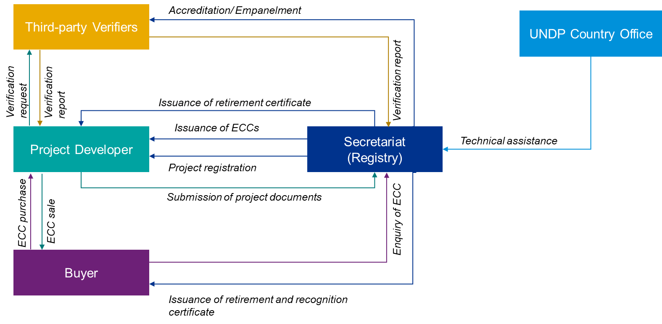

**Secretariat**: A committee set up to operationalize and administer the Ethiopian voluntary domestic carbon market. The secretariat is responsible for approval and registration of project developers, accreditation of verifiers, maintenance of the Ethiopian Carbon Credit Registry (ECCR) and facilitating carbon trading between the project developers and buyers which includes issuance and cancellation of credits. The secretariat shall comprise of members from various ministries, which are the EFCCC, MoF, MUDC and CRGE as these institutions are currently responsible for governing national-level policies and supporting projects etc. that aligns with our scope for designing a carbon market in Ethiopia. The secretariat shall implement the following activities:

* Facilitating carbon trading in Ethiopia between project developers and buyers, which includes amongst others:
  + Upload a project details on the registry website
  + Review and approve verification reports submitted by a project developer
  + Issue credit certificates to project developers after the documents have been verified
  + Maintain an excel spreadsheet that record details for projects that have been registered on the registry. The record shall include details such as project name, project developer, ECCs issued and ECCs retired.
  + Invite interested buyers to purchase credits by executing awareness campaigns and other similar activities
  + Issue certificate of retired credits to buyers to avoid double counting, by ensuring retirement of records from seller’s account
* Accreditation of third-party verifiers
  + Exercise due diligence for providing accreditation to verifiers in the secretariat, based on the requirements for a recognized verifier
* Seeking technical assistance from the UNDP

While, the Secretariat has been proposed to comprise of members from various ministries it is flexible to include members from any one of the suggested ministries to house the secretariat.

The personnel from these institutions will be given additional responsibilities for performing tasks that are mentioned above to facilitate the functioning of the carbon market in Ethiopia.

**Project Developer:** An individual, organization or a group, implementing mitigation project(s) with an aim to sell the emission reductions achieved in the Ethiopian voluntary carbon market. A project developer is responsible for submitting the project application form (project submission), monitoring of project activities periodically (monitoring), reporting validated and verified reports to the secretariat (reporting), and getting projects verified by an independent third-party, which has received accreditation as part of the ECCR.

**Buyer:** An organization (public or private) interested in purchasing Ethiopian carbon credits from project developer(s) listed on the ECCR. The demand for these units is driven by competition that arises among domestic players that are registered on international registries; or the ones that are interested in voluntarily offsetting their emissions. Once credits are bought by the buyers, they market themselves as a green and environmentally-conscious organization.

The buyer chooses the project developer from the list of developers available on the registry website for buying ECCs. Furthermore, a buyer negotiates for a price of credits with the selected project developer soon after which an agreement is signed between the two parties. The developer then requests the secretariat to retire these credits from its account and requests for issuance of credit certificates to the buyer.

**Independent third-party verifier:** An organization, accredited by the secretariat to validate the project information and verify emission reductions from projects, to support participation of project developers in the Ethiopian voluntary carbon market. A verifier needs to submit an application form to the secretariat, for getting accreditation. After being accredited, the verifier becomes eligible to validate new projects and verify emission reductions, which the developer seeks to register in Ethiopia’s registry. An accredited verifier should fulfil the following requirements to get accreditation in the Secretariat:

* Previously assessed proposed methodologies that are submitted by project developers in the areas of waste handling and disposal; and Agriculture, Forestry and Other Land Use
* Remain independent of the activity being verified, and free from bias and conflict of interest on the verification engagement.
* Maintain objectivity throughout the verification to ensure that the findings and conclusions are based on objective evidence generated during the verification.
* Demonstrate ethical conduct through trust, integrity, confidentiality and discretion throughout the verification process.
* Ensure there are no risks involved to the facility or business as a result of undertaking a verification engagement. A few risks involved are in terms of time and resource allocation to the verification engagement.
* Should have prior experience in conducting projects/ activities in the relevant sector
* Completed a training programme of minimum 40 hours in areas relevant for the verification exercise as detailed in table 4 and 5.

**Table 4: Sector-based technical requirements for a verifier**

| **Sector** | **Technical knowledge requirement** |
| --- | --- |
| Afforestation and reforestation | * Quantification of carbon stocks and change in carbon stocks in biomass of trees and shrubs, dead wood and litter, and soil organic carbon * GHG emissions attributable to the displacement (shift) of pre-project agricultural activities * Definition and identification of degraded and degrading lands |
| Waste handling and disposal | * Alternative methods for disposal, management and treatment of waste * Types of solid waste and wastewater, their composition, characterization parameters and impact of composition on decay rates and GHG emissions * Type of manure, their composition, characterization parameters and impact of composition on decay rates and GHG emissions * Types of livestock, dietary factors and their impact on manure generation |
| Agriculture | * GHG emissions from the production and application of synthetic and organic fertilizers, urea, dolomite and limestone; carbon stocks in the soil and land management practices * GHG emissions attributable to the displacement (shift) of pre-project agricultural activities * Agricultural operations and its main GHG emission sources * Use of fossil fuels and electricity in agricultural operations and methods to quantify their use and corresponding GHG emissions * Field burning of biomass and GHG emissions * Carbon stocks in the soil and land management practices * Definition and identification of degraded and degrading lands |
| Other sectors | * GHG emissions accounting and monitoring method for the particular sector |

The technical knowledge for validation and verification is defined in the table 5 below:

**Table 5: Verification technical knowledge**

| **Knowledge area** | **Verification technical knowledge** |
| --- | --- |
| Baseline establishment | * Baseline establishment in methodologies applied in the project * Project evaluation and investment decision theory * Net present value (NPV) and internal rate of return (IRR) rules of investment appraisal * Investment under uncertainty and sensitivity analysis * Establishment of baseline scenarios based on various approaches, such as historical emissions, monitored data, benchmarking, top performers in similar activities, best available technologies, most attractive alternative technology and standard values. |
| GHG accounting and monitoring | * + Greenhouse gases eligible under the Kyoto Protocol   + Definition of project boundaries, gases and emission sources   + Use of Global Warming Potential and conversion of non-CO2 GHG to equivalent CO2 emissions   + Direct measurement of GHG emissions using flow meters and gas analysis * Indirect evaluation of GHG emissions:   + Use of GHG standard emission factors based on energy content and service level: * Combustion of solid, liquid and gaseous fuels and approaches to evaluate GHG emissions from fuel combustion * Evaluation of GHG emissions from heat and power generation by means of GHG emission factors and quantification of energy use * Use of mass and energy balances in the evaluation of GHG emissions   + Metrology and the measurement of physical properties   + Quality control of measurements, including the concepts of measurement range, measurement uncertainty (accuracy, precision and bias) and meter calibration |

Some of the key responsibilities of a verifier would be as follows:

**Table 6: Key responsibilities of a verifier**

| **For Validation of Projects** | **For Verification of Projects** |
| --- | --- |
| Assess if the project documents (business licenses, registration certificate, project clearance, EIA etc.) submitted to the secretariat are in order and comply with the legal requirements of the country. | Assess if the project activity is implemented and operated as per the methodology; and if the physical infrastructure such as technology, project equipment, and monitoring and metering equipment is in place |
| Assess if the project does not lead to any adverse impacts to environment and society incase an EIA has not been undertaken for the same. | Examine if the monitoring report and other supporting documents provided are complete in accordance with the requirements of the chosen global standard |
| Assess whether the monitoring systems and procedures comply with the monitoring systems and procedures described in the monitoring plan and the approved methodology |
| Examines if data that is recorded and stored is as per the monitoring methodology |
| Checks for inconsistencies in the calculation of emission reduction |

# Market Design

## Market Workflow

This section entails the entire process of credit trading between project developers and buyers and has been categorized into the following 3 key stages:

Figure 5: Market process



### Registration and Approval of Projects

This stage details the process for project developers who wish to register their upcoming and/or existing projects in the market and their interactions with the secretariat. The registration and approval of projects should preferably be done before implementation of the project. In case the project is already operational, and the developer would like to register the same process (detailed below) should be followed. However, the start date of registration will be considered to be the base year from which emission credits will be generated. The key steps under this process have been detailed below in the figure and in the following sections:

Figure 6: Key activities under registration and approval of projects

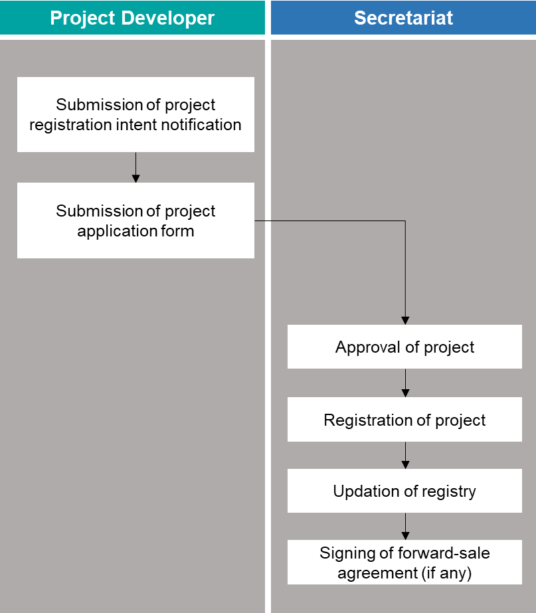

**Submission of project registration intent notification**: The project developer will inform the secretariat about the project by submitting a project registration intent notification letter before developing the project application form. The project registration intent notification letter comprises of the following:

* Project description which should include all details of the project such as type, size, location and duration along with information on the population/community that is likely to get affected due to the proposed project.
* Project developer details such as name, description of services and contact details.
* Credit generation potential which should include details on the baseline emissions i.e. the business-as-usual (BAU) and absolute reductions from the BAU scenario.
* Co-benefits to environment and society such as employment generation and health benefits.

**Submission of project application form:** The project developer will develop a detailed project application form for submission. The project developer will submit this form to the secretariat along with all the requisite supporting documents. The project application form comprises of the following:

* Project description include all details such as technologies/measures implemented/to be implemented by the project
* Sectoral scope of the project
* Project start date, scale, and crediting period
* Application of methodology
* Estimated GHG emission reductions and removals
* Monitoring parameters and plan
* Environment and social impact assessment

**Approval and registration of project:** If the submitted documents are in accordance with the set requirements, the secretariat will approve and register the project. The secretariat will confirm the registration of the project to the project developer.

**Updation of registry:** The secretariat will update the following project details on the registry from the project document:

* Project name
* Project description
* Project location
* Project developer details
* Credits generation potential (emissions reduction potential)
* Project developer’s contact details

Updating project details at this stage is important as buyers who wish to purchase credits from these projects can select the projects for forward transactions.

**Signing of forward-sale agreement (if any):** Based on the project details on the registry, the buyer is free to contact the project developer and sign a forward-sale agreement. The agreement implies that the buyer confirms to purchase the credits from the selected project developer once they are verified and registered by the secretariat in the future. The forward-sale agreement shall be signed between the buyer, project developer and secretariat. A template of the purchase agreement will be available on the registry for reference. However, the terms and conditions in the agreement will be finalized between the project developers and buyers.

### Issuance of Verified Credits

This stage details the process for project developers who wish to register their verified credits in the registry and their interactions with the secretariat and third-party verifiers. Verification should preferably happen a year after the project has been implemented and at the end of each following year till the end of registered crediting cycle. However, the project developer is free to set the frequency of the verification process based on requirement, which should be reported to the secretariat as part of the project application form. The key steps under this process have been given in the figure below and in the following sections:

Figure 7: Key activities under issuance of verified credits

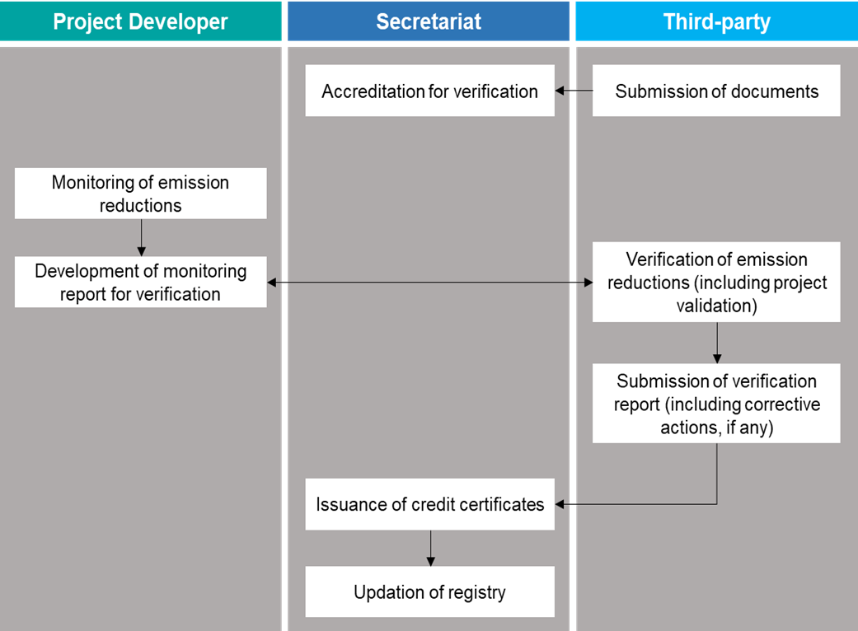

**Monitoring of emission reductions:** The project developer shall estimate emission reductions for composting and afforestation projects based on the methodology developed under the COMPOST NAMA programme and in accordance with the monitoring plan submitted as part of the validation report. For other projects/sectors estimation of emission reductions shall be performed in accordance with any internationally recognized and approved methodology (as suggested in section 2.2 and Annexure III). Going forward, as and when a national level MRV mechanism is developed, the same can be used for project specific MRVs in future.

**Development of monitoring report for verification:** The project developer shall develop a monitoring report detailing the emission reduction estimates along with details on the project’s co-benefits. The report should include the measurement methodology and the monitoring plan adopted. The report should be submitted to the verifiers for the purpose of verification.

**Verification of emission reductions:** The project developer shall appoint a third-party verifier for verifying the emission reductions from the list of verifiers accredited by the Secretariat. The list of accredited third-party verifiers shall be available on the registry. The verifier shall be responsible for validating the project details and documents along with verifying emission reduction estimates. The third-party verification of co-benefits monitored and reported by the project developer is optional and could be included as part of the verification process based on the requirement of project developer.

The project developer shall ensure that the verification is conducted based on the quality control guidelines specified in the standard used. The verification process shall consist of the following:

* Signing of contract between project developer and third-party verifier
* Review of project details, project documents, monitoring report and other supporting documents
* On-site assessments and interviews with personnel of the project developer
* Provision of list of corrective actions[15] and clarification requests[16] (if any)
* Preparation of draft verification report
* Resolution of corrective actions and clarification requests (if any)
* Finalization of verification report
* Submission of verification report to the secretariat

In case the project is already operational and would like to register for credit trading in the market, the verification report shall be submitted along with the project application form for registration.

**Submission of verification report:** The verifier shall submit the final verification report which will include a verification certificate confirming the credits generated from the project to the secretariat and the project developer.

**Issuance of credit certificates:** Based on the verification report submitted by the third-party verifier, the secretariat shall issue credit certificates to the project developer as proof against registration of verified credits. The template of the credit certificate has been provided in the operational manual “Ethiopia Voluntary Carbon Market Design – Operational Manual”.

**Updation of registry:** The secretariat shall update the registry to add details of the verified credits.

### Purchase and Retirement of Ethiopian Carbon Credits (ECC)

This stage details the process for buyers who wish to purchase credits from the registry to offset their emissions; and their interactions with the secretariat and project developers. The key steps under this process have been given in the figure below and in the following sections:

Figure 8: Key activities under purchase and retirement of credits

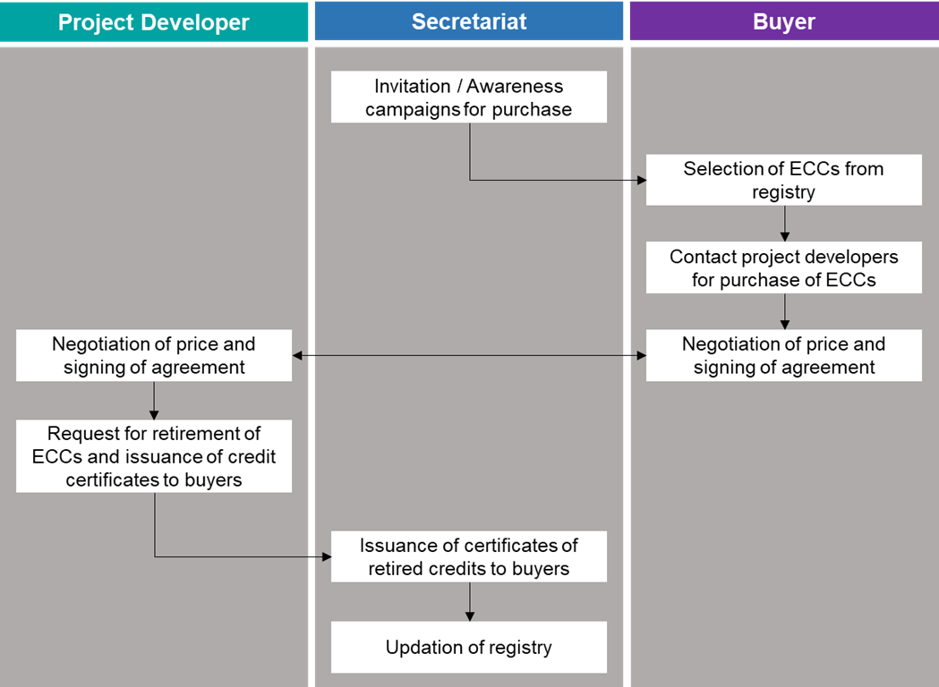

**Invitation/ awareness campaigns for purchase:** The secretariat shall at regular intervals inform the potential buyers (public companies, private companies and industries, and bi/multi-lateral agencies) about the type of projects registered and verified and invite them to purchase credits from these projects. This will ensure that the companies are aware of the projects and achievements and accordingly integrate it in their emission reduction strategies.

**Selection of ECCs from registry:** The buyers who wish to purchase credits can select the them from the list of projects that will be available on the registry. While selection of ECCs the buyers are free to enquire more about the projects from the secretariat and project developers through email and/or post.

**Contact project developers for purchase of ECCs:** After selection of credits the buyers are free to directly contact the project developers and negotiate a price at which they wish to buy the credits.

**Signing of purchase agreement:** Upon finalization of the credit price, and the terms and conditions, a contract shall be established between the project developer, buyer and the secretariat. A draft template of contract shall be available on the registry for use/reference. The project developers and buyers are free to negotiate and add their own terms and conditions in the contract. The template of the contract has been provided in the operational manual.

**Request for retirement of ECCs and issuance of credit certificates to buyers:** After signing of the contract, the project developer shall request the secretariat in writing to retire their credit certificates and to issue certificates of retired credits to buyers. The template of the request letter has been provided in the operational manual. The project developers are required to disclose the price at which the credits are being sold to the secretariat, in the request letter submitted to the secretariat for record keeping.

**Issuance of certificates of retired credits to buyers:** After signing of the contract, the secretariat shall issue an ECC retirement certificate to the buyer implying that the credits have been retired from the project developer’s account for use by buyer to offset their emissions. A copy of the retirement certificate will also be sent to the project developer.

The ECC retirement certificate to the buyers will be accompanied with a recognition certificate stating the benefits received to the environment and society due to the implemented project.

**Updation of registry:** The secretariat shall update the registry to remove details of the credits retired from the project developer’s account.

## Credit Trading Cycle

The credit trading cycle, specifying indicative timelines (can change based on the appetite of the secretariat) of all activities starting from submission of project registration application to purchase of credits by buyers, has been provided below:

Figure 9: Credit trading cycle

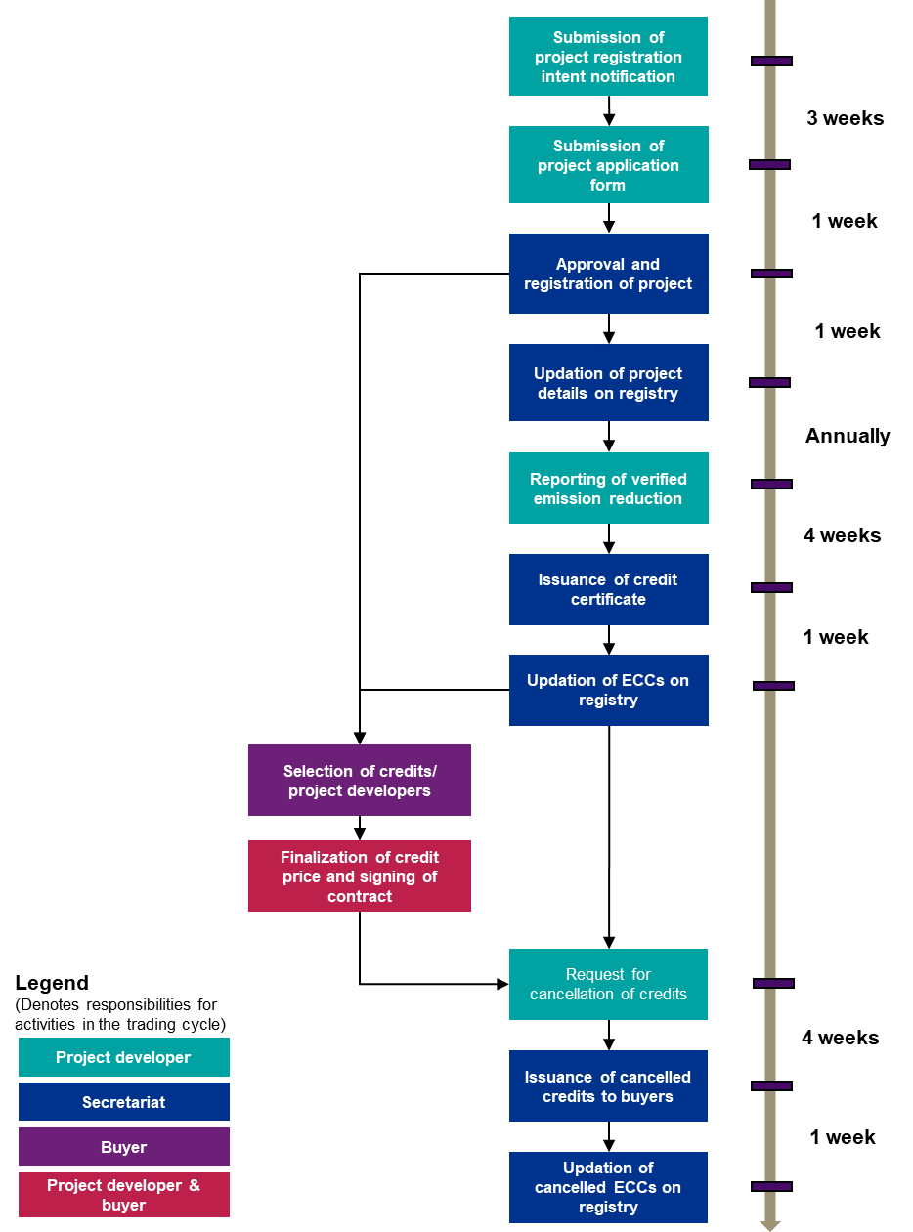

## Financial Framework

The proposed flow of finances between all market participants have been detailed below:

Figure 10: Financial flow between market participants

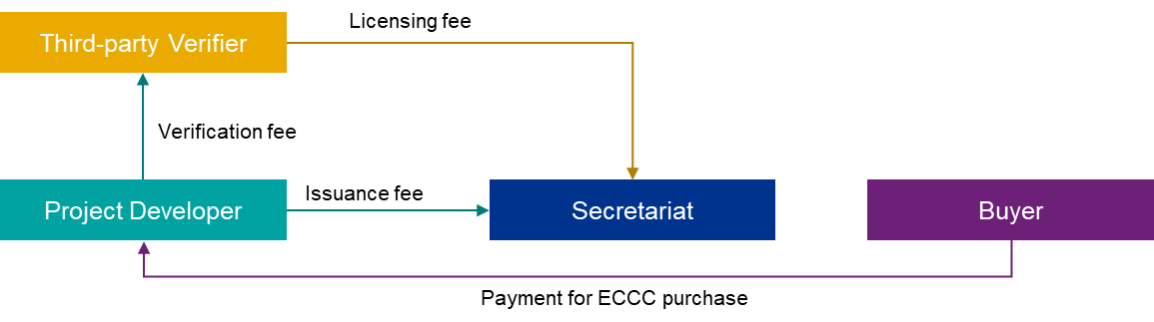

The secretariat shall charge a small fee for providing the administrative services required for the functioning of the carbon market. This fee will help cater to the secretariat’s expenses such as salaries, administration costs, and IT costs. This involves charging an issuance fee to the project developers and a license fee to the third-party verifiers. The issuance fee shall be a fixed fee that will be paid by the project developers before every issuance of ECCs. This fee will be charged in lieu of services provided by the secretariat for issuance and retirement of credits.

The secretariat will also charge a license fee to the third-party verifiers at the time of accreditation and at the time of the renewal (biennially) of its license in lieu of services provided by the secretariat for accreditation of the verifiers.

These charges shall be set by the secretariat based on the estimated time and resource requirement and shall be utilized for the secretariat’s operations.

Apart from this, the project developer shall pay a verification fee to the third-party verifiers appointed for verification of emission reductions as per their contractual agreement.

Similarly, the buyers shall pay for the ECCs purchased directly to the project developers as per the price set in individual signed contracts.

As mentioned in the forestry proclamation all project beneficiaries involved in the development and maintenance activities of the forestry projects should receive all benefits from the sale of carbon credits. Similarly, it is recommended that all benefits received by the project developer towards the sale of carbon credits from all other mitigation projects in sectors such as waste, should also be equitably distributed amongst all project beneficiaries responsible for developing and managing the credit generating project.

## Secretariat’s Operational Framework

The operational framework for the market has been developed considering the activities planned in the market workflow and the financial framework. This framework details the minimum administrative requirements for efficient functioning of the secretariat considering all internal and external interactions. The framework has been presented in the figure below:

Figure 11: Operational framework

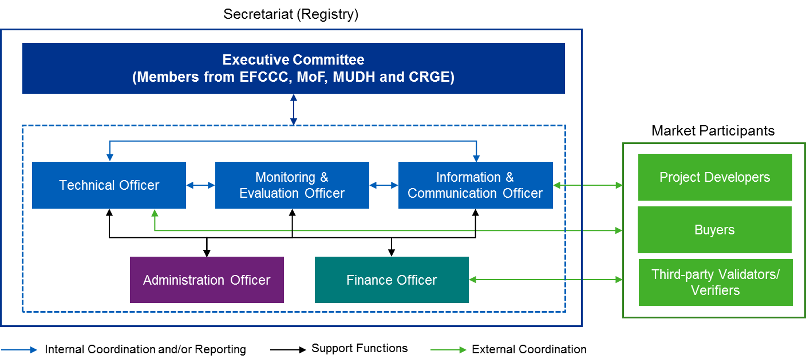

The secretariat shall consist of officers responsible for technical assessment, monitoring and evaluation of market performance, marketing and communication, administrative support and financial support. These officers could be personnel from existing ministries responsible for conducting similar activities and/or new personnel having relevant expertise to undertake the tasks.

At the outset, an individual can be assigned multiple roles as long as the requirements are met. The officers shall function under the oversight of an executive committee which will be a representation of all relevant ministries responsible for the market.

The key roles of the executive committee and all officers have been detailed in the following sub-sections:

### Executive Committee

The committee shall consist of members from EFCCC, MoF, MUDC and CRGE and shall be responsible for overall governance and management of the secretariat. The committee shall be headed by a chairperson elected by all members of the committee.

The executive committee shall be responsible for the following key functions:

* Appointment of technical and support staff
* Delegation of responsibilities to technical and support staff
* Setting of operating procedures, guidelines and standards to ensure effective functioning of the secretariat
* Conducting a detailed risk assessment and developing a risk mitigation plan
* Ensuring compliance with the procedures and operational ethics
* Final approval of projects for registration on registry
* Support regular financial audits

### Technical Officer(s)

The technical officer shall be responsible for managing the entire process of carbon trading directly with project developers and buyers. The technical officer’s key functions have been detailed below:

* Review of project documents, licenses, certificates, contractual agreement document and any other relevant document submitted by project developers
* Periodic reporting of the submitted projects to the executive committee for approval and project registration
* Evaluation of verification report and issuance of ECC certificates to project developers
* Issuance of certificates of retired credits to buyers
* Accreditation of verifiers
* Periodic reporting of the submitted accreditation requests to the executive committee for approval and accreditation
* Coordination with information and communication officer about the project and verified ECCs
* Supporting the monitoring and evaluation officer through provision of relevant documents and information

### Monitoring and Evaluation Officer(s)

The monitoring and evaluation officer shall be responsible for monitoring, reporting and verification of key market performance indicators. The monitoring and evaluation officer should have experience and technical capacity in development and implementation of sectoral MRVs (active sectors such as waste and afforestation). The officer should be able to develop emission baselines and estimate mitigation potential from atleast composting and reforestation projects.

The key functions of the monitoring and evaluation officer are detailed below:

* Periodically monitoring the key performance indicators in the set templates in coordination with technical and financial officers
* Reporting results from the monitoring exercise to the executive committee annually
* Support in disclosure of results from the monitoring exercise on various platforms (domestic and/or international)
* Develop and/or update templates as and when the scope of the market is revised

### Information and Communication Officer(s)

The information and communication officer shall be responsible for all activities around information dissemination, and internal as well as external communications with all relevant stakeholders and members of the secretariat. The officer should have knowledge and experience on carbon markets as well as an understanding on the key elements to be reported. The key functions of information and communication officer are detailed below:

* Managing and regularly updating the registry with details of validated project, verified and retired ECCs, and other required information as detailed in the operational manual/ guidelines.
* Regularly conducting awareness programs to promote the voluntary market amongst the project developers and buyers (private, public and DFIs)
* Preparing promotional and/ or knowledge sharing and dissemination materials such as brochures, briefs, etc.

### Administration Officer(s)

The administration officer will be responsible to provide support to all other units and committees for their effective functioning. The officer will also act as a single point of contact between the executive committee and the rest of the officers. Its key functions are detailed below:

* Support the executive committee during appointment of professionals/experts
* Maintaining/ archiving all documents submitted by project developers
* Managing and regularly updating the registry with project and ECC details, along with any required information detailed in the operational manual/guidelines.
* IT related support to all other officers and the executive committee
* Any other activity that will support the functioning of secretariat such as infrastructure maintenance.

### Finance Officer(s)

The finance officer shall be responsible for managing and accounting for the money received from the project developers and verifiers and utilized for various services for functioning of the secretariat. The key functions of the finance officer are detailed below:

* Managing and disbursing finances as and when required
* Maintaining accounts and balance sheets
* Periodically reporting the finances received and utilized, to the executive committee
* Supporting third-party financial auditors with all relevant documents and data

## Integrating the Operational Framework into EFCCC Structure

Since the EFCCC has the mandate (refer section 2.7.) and relevant experience for developing and implementing a domestic carbon market in Ethiopia, the proposed operational framework can be established as a new, standalone directorate within the EFCCC or can be integrated within EFCCC’s current structure.

With respect to the establishment of a new standalone directorate, the EFCCC can utilise existing resources within the commission moving them into the new roles as defined under the secretariat or bring in new resources at an additional cost to drive the operations of the secretariat.

With regards to the latter, the proposed roles and responsibilities will be assigned to personnel who currently perform similar jobs under various existing directorates and case teams within EFCCC. This integration should allow the EFCCC to minimize the operationalization cost of the market as well as reduce the capacity development requirements but will entail providing additional responsibilities to existing resources within the commission.

### Executive Committee

The executive committee shall consist of representatives from various directorates within EFCCC as detailed in the figure below. This will ensure that all key activities and decisions are taken in consultation with representatives from all teams.

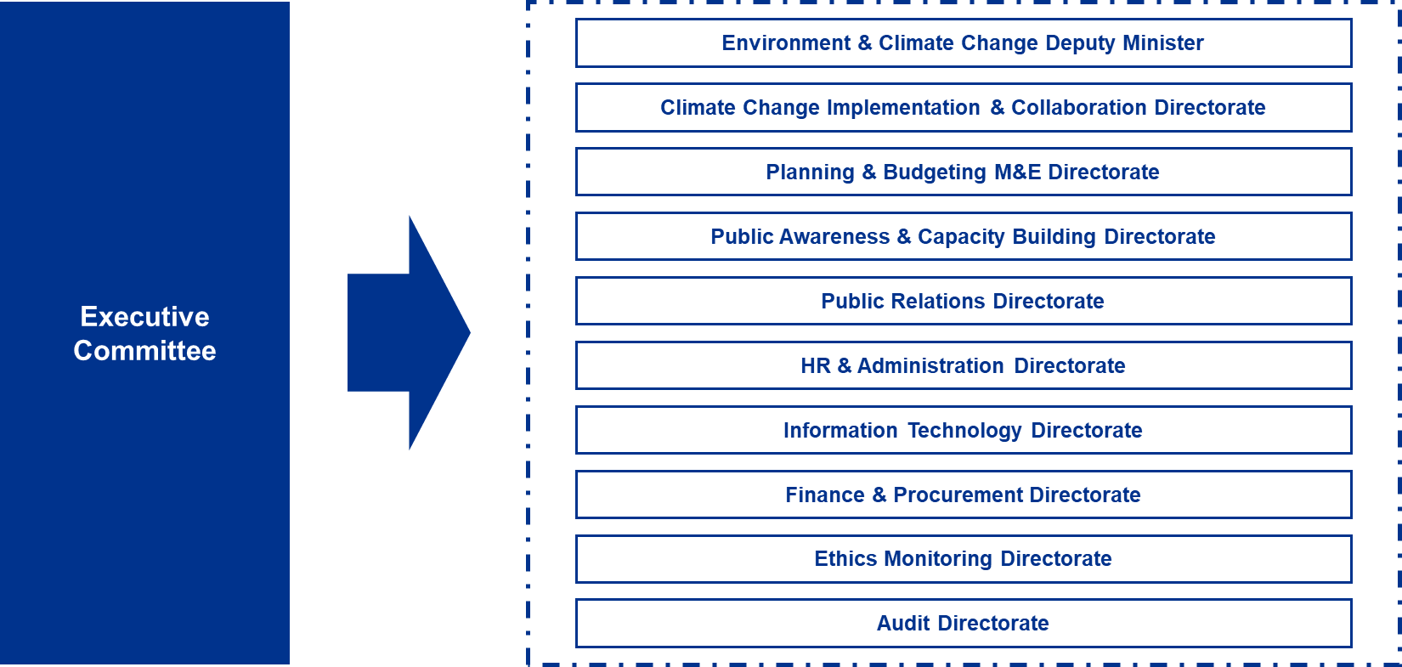

### Technical Officer

The role of a technical officer(s) could be assigned to personnel/teams from the climate change implementation and collaboration directorate as they currently have similar job profiles.

* The resource mobilization, outreach and project M&E case team has the requisite technical experience in carbon markets due to participation in CDM activities and shall have the required expertise to evaluate all types of project application forms, GHG baselines and verification reports.
* The members from GHG reduction and verification case team, who currently support the resource mobilization, outreach and project M&E case team in developing and reviewing the MRV baselines for CDM projects, have also been proposed to be part of the technical team.



### Monitoring and Evaluation Officer

The role of monitoring and evaluation officer could be assigned to personnel/teams from the planning and budgeting M&E directorate, who are currently tracking and evaluating the status, progress, and budget of all projects implemented by EFCCC. Representatives from the planning implementation M&E case team, and budgeting and implementation M&E case team within the directorate have been proposed to cover all project and finance-related aspects to be monitored as part of the market MRV (refer section 4.6 for the monitoring indicators).

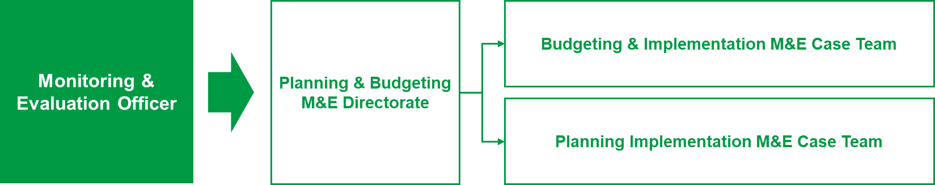

### Information and Communication Officer

The role of the information and communication officer(s) could be assigned to personnel/teams from the public awareness and capacity building directorate and/or public relations directorate as the roles and responsibilities proposed for the officer are currently being handled by various teams in the two directorates.



### Administration Officer

The role of the administration officer could be assigned to personnel/ teams in the HR and administration directorate and information technology directorate. The roles and responsibilities of the administration officer include hiring of personnel, managing database, managing infrastructure along with providing IT related support which is currently being handled by various teams in the directorates.

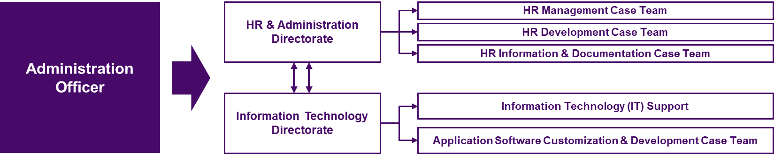

### Finance Officer

The role of the finance officer could be assigned to personnel/teams from the finance and procurement directorate, and the planning and budgeting M&E directorate. The roles and responsibilities for the finance officer include managing finances, maintaining accounts, monitoring finance related indicators along with providing support during audits which are currently being handled by various teams within both directorates.

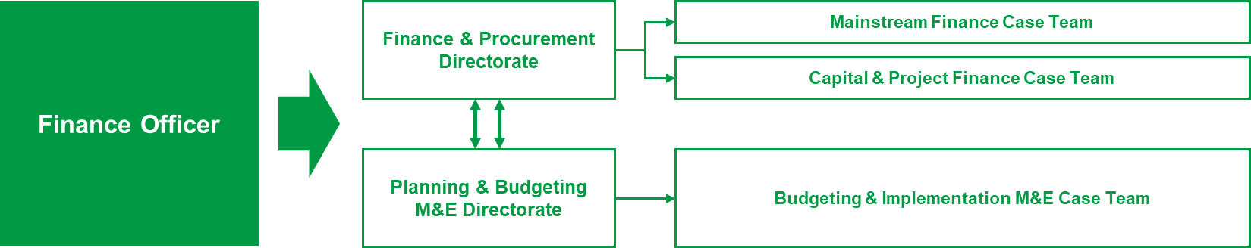

## Monitoring, Reporting and Verification of Market

In order to track the success of the proposed market, Monitoring, Reporting and Verification (MRV) of the key activities of the market is of utmost importance. An MRV framework for the Ethiopian carbon market has been designed and detailed in the following sections. This framework will enable tracking of year-on-year improvements in the number and type of projects registered, emission reductions achieved, finances mobilized and public/private participation. The process that will be followed for MRV is as follows:

### Monitoring

Monitoring of all the key indicators shall be done by the secretariat. The key indicators to be monitored have been detailed in the following table with their sources.

Table 6: Key indicators to be monitored

| **S. No.** | **Indicator** | | **Unit** |
| --- | --- | --- | --- |
| 1 | Number of projects registered | Total | Nos. |
| Waste sector |
| Afforestation sector |
| Other sectors |
| 2 | Number of ECCs issued | Total | Nos. |
| Waste sector |
| Afforestation sector |
| Other sectors |
| 3 | Number of ECCs purchased | Total | Nos. |
| Private companies |
| Public companies |
| Others (e.g. DFIs) |
| 4 | Finance mobilized through sale of ECCs | Total | Birr |
| Private companies |
| Public companies |
| Others (e.g. DFIs) |
| 5 | Number of market participants | Project developers | Nos. |
| Private companies |
| Public companies |
| Verifiers |
| Others (e.g. DFIs) |
| 6 | Funds received by secretariat | Project developers | Birr |
| Verifiers |
| Government |
| External Sources (e.g. DFIs) |
| 7 | Funds utilized by secretariat | Salaries | Birr |
| Infrastructure |
| Awareness activities |
| Others |
| 8 | Employment generation | People hired in the secretariat | Nos. |

The aforementioned indicators have been detailed below:

* **Number of Projects Registered**

|  |  |
| --- | --- |
| **Description** | The total number of projects registered in the ECCR in a particular year. This indicator will help assessing the reliability of supply-side of the market. |
| **Data Unit** | Nos. |
| **Source of Data** | Project application form/ Registration records maintained by the technical officer |
| **Frequency** | Monthly |
| **Measurement Procedure** | The number of registrations shall be tracked on a monthly basis in set templates. |

* **Number of Waste Projects Registered**

|  |  |
| --- | --- |
| **Description** | The total number of composting projects registered in the ECCR in a particular year. This indicator will help assessing the reliability of supply-side of the market. |
| **Data Unit** | Nos. |
| **Source of Data** | Project application form/ Registration records maintained by the technical officer |
| **Frequency** | Monthly |
| **Measurement Procedure** | The number of registrations shall be tracked on a monthly basis in set templates. |

* **Number of Afforestation Projects Registered**

|  |  |
| --- | --- |
| **Description** | The total number of afforestation projects registered in the ECCR in a particular year. This indicator will help assessing the reliability of supply-side of the market. |
| **Data Unit** | Nos. |
| **Source of Data** | Project application form/ Registration records maintained by the technical officer |
| **Frequency** | Monthly |
| **Measurement Procedure** | The number of registrations shall be tracked on a monthly basis in set templates. |

* **Number of Other Sector Projects Registered**

|  |  |
| --- | --- |
| **Description** | The total number of projects registered under sectors other than waste and forestry sector in the ECCR in a particular year. This indicator will help assessing the reliability of supply-side of the market. |
| **Data Unit** | Nos. |
| **Source of Data** | Project application form/ Registration records maintained by the technical officer |
| **Frequency** | Monthly |
| **Measurement Procedure** | The number of registrations shall be tracked on a monthly basis in set templates. |

* **Number of ECCs Issued**

|  |  |
| --- | --- |
| **Description** | The total number of ECC certificates issued every year to the project developer. This indicator will help assessing the reliability of supply-side of the market. |
| **Data Unit** | Nos. |
| **Source of Data** | Records on credit certificates issued by technical officer |
| **Frequency** | Monthly |
| **Measurement Procedure** | The number of ECCs issued shall be tracked on a monthly basis in set templates. |

* **Number of ECCs Issued in Waste Sector**

|  |  |
| --- | --- |
| **Description** | The total number of ECC certificates issued every year to a project developer implementing a composting project. This indicator will help assessing the reliability of supply-side of the market. |
| **Data Unit** | Nos. |
| **Source of Data** | Records on credit certificates issued by technical officer |
| **Frequency** | Monthly |
| **Measurement Procedure** | The number of ECCs issued shall be tracked on a monthly basis in set templates. |

* **Number of ECCs Issued in Afforestation Sector**

|  |  |
| --- | --- |
| **Description** | The total number of ECC certificates issued every year to a project developer implementing an afforestation project. This indicator will help assessing the reliability of supply-side of the market. |
| **Data Unit** | Nos. |
| **Source of Data** | Records on credit certificates issued by technical officer |
| **Frequency** | Monthly |
| **Measurement Procedure** | The number of ECCs issued shall be tracked on a monthly basis in set templates. |

* **Number of ECCs Issued in Other Sectors**

|  |  |
| --- | --- |
| **Description** | The total number of ECC certificates issued every year to a project developer implementing an projects in sectors other than waste and afforestation. This indicator will help assessing the reliability of supply-side of the market. |
| **Data Unit** | Nos. |
| **Source of Data** | Records on credit certificates issued by technical officer |
| **Frequency** | Monthly |
| **Measurement Procedure** | The number of ECCs issued shall be tracked on a monthly basis in set templates. |

* **Number of ECCs Purchased**

|  |  |
| --- | --- |
| **Description** | The number of ECCs purchased in different sectors in a year. This will help in assessing the reliability of the demand-side of the market and sectoral demand for credits purchase. |
| **Data Unit** | Nos. |
| **Source of Data** | Request letters for retirement of credits submitted by project developers |
| **Frequency** | Monthly |
| **Measurement Procedure** | The number of ECCs purchased shall be tracked on a monthly basis in set templates. |

* **Number of ECCs Purchased by Private Players**

|  |  |
| --- | --- |
| **Description** | The number ECCs purchased by private players in different sectors in a year. This will help in assessing the reliability of the demand-side of the market and sectoral demand for credits purchase. |
| **Data Unit** | Nos. |
| **Source of Data** | Request letters for retirement of credits submitted by project developers |
| **Frequency** | Monthly |
| **Measurement Procedure** | The number of ECCs purchased by private players shall be tracked on a monthly basis in set templates. |

* **Number of ECCs Purchased by Public Players**

|  |  |
| --- | --- |
| **Description** | The number ECCs purchased by public players in different sectors in a year. This will help in assessing the reliability of the demand-side of the market and sectoral demand for credits purchase. |
| **Data Unit** | Nos. |
| **Source of Data** | Request letters for retirement of credits submitted by project developers |
| **Frequency** | Monthly |
| **Measurement Procedure** | The number of ECCs purchased by public players shall be tracked on a monthly basis in set templates. |

* **Number of ECCs Purchased by Other Players**

|  |  |
| --- | --- |
| **Description** | The number of ECCs purchased by other players such as DFIs in different sectors in a year. This will help in assessing the reliability of the demand-side of the market and sectoral demand for credits purchase. |
| **Data Unit** | Nos. |
| **Source of Data** | Request letters for retirement of credits submitted by project developers |
| **Frequency** | Monthly |
| **Measurement Procedure** | The number of ECCs purchased by other players shall be tracked on a monthly basis in set templates. |

* **Finance Mobilized for Purchase of ECCs**

|  |  |
| --- | --- |
| **Description** | Amount of finance mobilized every year from private, public and other players within Ethiopia |
| **Data Unit** | Birr |
| **Source of Data** | Request letters for retirement of credits submitted by project developers will provide credit purchase price |
| **Frequency** | Monthly |
| **Measurement Procedure** | Finance mobilized for purchase of ECCs shall be estimated using the details on carbon price and number of ECCs retired specified in the request letters submitted by the project developers to technical unit and tracked on a monthly basis in set templates. |

* **Finance Mobilized from Private Players for Purchase of ECCs**

|  |  |
| --- | --- |
| **Description** | Amount of finance mobilized every year from private players within Ethiopia |
| **Data Unit** | Birr |
| **Source of Data** | Request letters for retirement of credits submitted by project developers will provide credit purchase price |
| **Frequency** | Monthly |
| **Measurement Procedure** | Finance mobilized for purchase of ECCs shall be estimated using the details on carbon price and number of ECCs retired specified in the request letters submitted by the project developers to technical unit and tracked on a monthly basis in set templates. |

* **Finance Mobilized from Public Players for Purchase of ECCs**

|  |  |
| --- | --- |
| **Description** | Amount of finance mobilized every year from public players within Ethiopia |
| **Data Unit** | Birr |
| **Source of Data** | Request letters for retirement of credits submitted by project developers will provide credit purchase price |
| **Frequency** | Monthly |
| **Measurement Procedure** | Finance mobilized for purchase of ECCs shall be estimated using the details on carbon price and number of ECCs retired specified in the request letters submitted by the project developers to technical unit and tracked on a monthly basis in set templates. |

* **Finance Mobilized from Other Players for Purchase of ECCs**

|  |  |
| --- | --- |
| **Description** | Amount of finance mobilized every year from other players such as DFIs within Ethiopia |
| **Data Unit** | Birr |
| **Source of Data** | Request letters for retirement of credits submitted by project developers will provide credit purchase price |
| **Frequency** | Monthly |
| **Measurement Procedure** | Finance mobilized for purchase of ECCs shall be estimated using the details on carbon price and number of ECCs retired specified in the request letters submitted by the project developers to technical unit and tracked on a monthly basis in set templates. |

* **Number of Market Participants**

|  |  |
| --- | --- |
| **Description** | The total number of market participants such as project developers, verifiers, buyers, etc. This will help assess the diversity in the types of players active in the market |
| **Data Unit** | Nos. |
| **Source of Data** | Registration records/ Request letters for retirement of credits submitted by project developers/ Records of certificates of retired credits issued by the technical unit |
| **Frequency** | Monthly |
| **Measurement Procedure** | The number of supply-side and demand-side players by other players shall be tracked on a monthly basis in set templates. |

* **Number of Project Developers**

|  |  |
| --- | --- |
| **Description** | The total number of project developers who have registered projects in the ECCR. |
| **Data Unit** | Nos. |
| **Source of Data** | Registration records maintained by the technical officer |
| **Frequency** | Monthly |
| **Measurement Procedure** | The number of project developers shall be tracked on a monthly basis in set templates. |

* **Number of Private Players**

|  |  |
| --- | --- |
| **Description** | The total number of private players who have purhased ECCs in the carbon market. |
| **Data Unit** | Nos. |
| **Source of Data** | Request letters for retirement of credits submitted by project developers/ Records of certificates of retired credits issued by the technical officer |
| **Frequency** | Monthly |
| **Measurement Procedure** | The number of private players shall be tracked on a monthly basis in set templates |

* **Number of Public Players**

|  |  |
| --- | --- |
| **Description** | The total number of public players who have purhased ECCs in the carbon market. |
| **Data Unit** | Nos. |
| **Source of Data** | Request letters for retirement of credits submitted by project developers/ Records of certificates of retired credits issued by the technical officer |
| **Frequency** | Monthly |
| **Measurement Procedure** | The number of public players shall be tracked on a monthly basis in set templates |

* **Number of Other Players**

|  |  |
| --- | --- |
| **Description** | The total number of other players such as DFIs who have purhased ECCs in the carbon market. |
| **Data Unit** | Nos. |
| **Source of Data** | Request letters for retirement of credits submitted by project developers/ Records of certificates of retired credits issued by the technical officer |
| **Frequency** | Monthly |
| **Measurement Procedure** | The number of other players shall be tracked on a monthly basis in set templates |

* **Number of Verifiers**

|  |  |
| --- | --- |
| **Description** | The number of accredited verifiers in various sectors |
| **Data Unit** | Nos. |
| **Source of Data** | Records on accredited verifiers maintained by technical officer |
| **Frequency** | Monthly |
| **Measurement Procedure** | The number of accredited verifiers shall be tracked on a monthly basis in set templates. Any verifier whose accreditation would have not been renewed in that particular year shall not be considered. |

* **Funds Received by the Secretariat**

|  |  |
| --- | --- |
| **Description** | The amount of funds received from the project developers, verifiers, government and external sources |
| **Data Unit** | Birr |
| **Source of Data** | Records maintained by the finance officer |
| **Frequency** | Monthly |
| **Measurement Procedure** | The amount received from the project developers, verifiers, government and external sources shall be tracked on a monthly basis in set templates |

* **Funds Received from Project Developers**

|  |  |
| --- | --- |
| **Description** | The amount of registration fee and issuance fee received from the project developers |
| **Data Unit** | Birr |
| **Source of Data** | Records maintained by the finance officer |
| **Frequency** | Monthly |
| **Measurement Procedure** | The amount received from the project developers shall be tracked on a monthly basis in set templates |

* **Funds Received from Verifiers**

|  |  |
| --- | --- |
| **Description** | The amount of annual fee received from the verifiers |
| **Data Unit** | Birr |
| **Source of Data** | Records maintained by the finance officer |
| **Frequency** | Monthly |
| **Measurement Procedure** | The amount received from the verifiers shall be tracked on a monthly basis in set templates |

* **Funds Received from Goverment**

|  |  |
| --- | --- |
| **Description** | The amount of funds received from the Government of Ethiopia for functioning of the secretariat |
| **Data Unit** | Birr |
| **Source of Data** | Records maintained by the finance officer |
| **Frequency** | Monthly |
| **Measurement Procedure** | The amount received from the government shall be tracked on a monthly basis in set templates |

* **Funds Received from External Sources**

|  |  |
| --- | --- |
| **Description** | The amount of funds received from the external sources such as DFIs for functioning of the secretariat |
| **Data Unit** | Birr |
| **Source of Data** | Records maintained by the finance officer |
| **Frequency** | Monthly |
| **Measurement Procedure** | The amount received from the government shall be tracked on a monthly basis in set templates |

* **Funds Utilized by the Secretariat**

|  |  |
| --- | --- |
| **Description** | The amount of funds utilized towards implementing various activities of the secretariat |
| **Data Unit** | Birr |
| **Source of Data** | Records maintained by the finance officer |
| **Frequency** | Monthly |
| **Measurement Procedure** | The amount utilized shall be tracked on a monthly basis in set templates |

* **Funds Utilized towards Payment of Salaries**

|  |  |
| --- | --- |
| **Description** | The amount of funds utilized towards payment of salaries to employees of the secretariat |
| **Data Unit** | Birr |
| **Source of Data** | Records maintained by the finance officer |
| **Frequency** | Monthly |
| **Measurement Procedure** | The amount utilized shall be tracked on a monthly basis in set templates |

* **Funds Utilized towards Infrastructure Development and Maintenance**

|  |  |
| --- | --- |
| **Description** | The amount of funds utilized towards infrastructure development and maintenance |
| **Data Unit** | Birr |
| **Source of Data** | Records maintained by the finance officer |
| **Frequency** | Monthly |
| **Measurement Procedure** | The amount utilized shall be tracked on a monthly basis in set templates |

* **Funds Utilized towards Awareness Creation Activities**

|  |  |
| --- | --- |
| **Description** | The amount of funds utilized towards awareness creation activities |
| **Data Unit** | Birr |
| **Source of Data** | Records maintained by the finance officer |
| **Frequency** | Monthly |
| **Measurement Procedure** | The amount utilized shall be tracked on a monthly basis in set templates |

* **Funds Utilized towards Other Activities**

|  |  |
| --- | --- |
| **Description** | The amount of funds utilized towards other activities |
| **Data Unit** | Birr |
| **Source of Data** | Records maintained by the finance officer |
| **Frequency** | Monthly |
| **Measurement Procedure** | The amount utilized shall be tracked on a monthly basis in set templates |

* **Employment Generation**

|  |  |
| --- | --- |
| **Description** | The number of technical and support staff hired in the secretariat for implementing various activities indicating the co-benefits of the designed market |
| **Data Unit** | Nos. |
| **Source of Data** | Records maintained by the administration officer |
| **Frequency** | Monthly |
| **Measurement Procedure** | The number of employees hired shall be tracked on a monthly basis in set templates |

### Reporting

The performance of the market measured against each indicator shall be reported/ published annually for all the stakeholders. The indicators shall be reported on the registry website annually and can also be included in the country’s National Communication (NATCOM) report and Biennial Update Report (BUR). The secretariat is responsible for preparing the performance reports to be uploaded annually.

### Verification

The data reported by the secretariat shall be verified by an independent third-party auditor. This exercise of verification shall be on an annual basis before reporting on public platforms. The third-party auditor can be a private company with a verification certificate highlighting experience working with carbon credits and shall be hired by the secretariat.

## Verification and Accreditation Process

The accreditation of verifiers, preferably government universities, shall be done by the secretariat. The verifier shall submit an application form for accreditation along with the proof of registration/ legal status, details of their lead verifier(s) and their qualifications. An accreditation certificate shall be provided to the accredited verifiers after the submitted documents have been reviewed by the secretariat. The verifiers shall consist of a team of lead verifier, verifier and technical experts.

The accredited verifiers shall be appointed directly by the project developers for verifying the emission reductions in accordance with the international/ national standards used at the time of validation. The international standard used for verification in the first year shall be the same for all subsequent years.

The process that will be followed by the verifier for verification is as follows:

Figure 12: Verification process

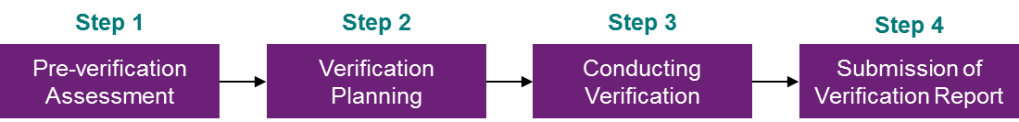

* **Pre-verification Assessment:** The verifier shall assess whether they are able to competently and objectively conduct the verification exercise for the project developer. This will include affirmation on the independence, objectivity and competence of the verification team and assessment of any risks that may arise for the verifier as a result of this engagement. In case of any conflicts, the project developer shall be informed by the verifier in a timely manner.
* **Verification Planning:** Verification planning shall be done to assess the objectives, nature and scale of the verification activities and also to assess the inherent risks to plan the verification activities along with developing a schedule of activities to be performed. The verification plan should be submitted to the project developer before conducting the verification.
* **Conduct Verification:** The verifiers shall ensure the following through relevant documents and data collected from the project developers along with on-site assessments:
  + The data monitoring has been performed as per the monitoring plan submitted in the project document
  + The methodology followed for emission reduction calculation is consisted with the MRV methodology provided in the validation report
  + The calculations are checked for any errors in emission reduction calculations

The verifiers shall ensure that evidence gathered during the course of the verification is sufficient to support the verification opinion.

* **Submission of Verification Report:** If the emission reductions are free from any errors and comply with the set methodologies, a verification report shall be issued by the verifier to the secretariat. The verifier shall ensure that all the corrective actions have been rectified before submitting the report.

The secretariat shall on its own or upon receipt of a complaint within 1 year from date of submission of verification report to the secretariat conduct a **‘check-verification’** on the project verification process undertaken for a particular project. The secretariat shall appoint a third-party verifier (called the check-inspector) from the list of verifiers accredited by the secretariat. The secretariat will ensure that the verifier appointed as inspector has not been involved in the same project previously since the inception of the project.

## ECC Pricing

In contrast to compliance markets where the credit price is typically fixed and/or consistent, the credit price in voluntary markets vary significantly. In 2016-17, globally the voluntary credit prices ranged from about USD 0.50/tCO2e (ETB 15/ tCO2e) to more than USD 50/tCO2e (ETB1500/ tCO2e), while the average price across all transactions was USD 3.0/tCO2e[17] (ETB 91/ tCO2e).

The average price recorded in Africa in 2016-17 was USD 4.2 (ETB 127/ tCO2e). In the first quarter of 2017-18, the average global carbon price recorded ranged from USD 3-6/ tCO2e (ETB 91-181/ tCO2e), while the actual price ranged from USD 0.1-70/ tCO2e (ETB 3-2,115/ tCO2e), but roughly half of the voluntary credits were transacted at under 1 USD /tCO2e[18] (ETB 30.2/ tCO2e). The figure below showcases average credit price across different regions and different projects in 2017-18.

Figure 13: Credit price across regions

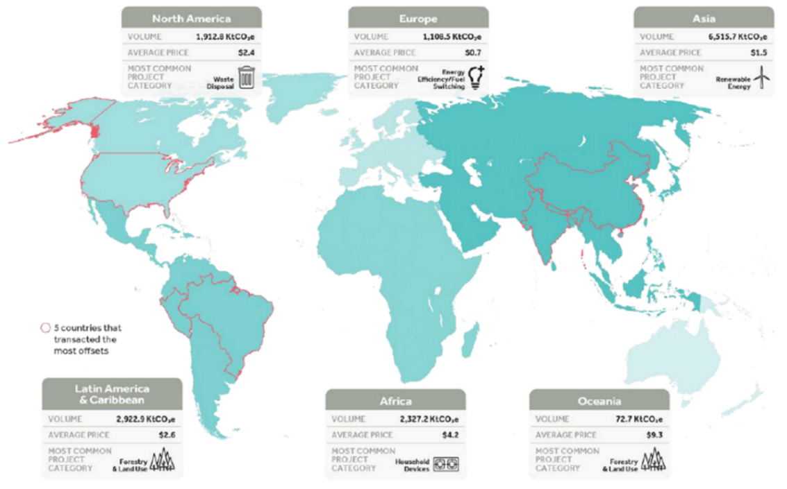

The average global carbon price in REDD+ and afforestation sectors were USD 4.2 (ETB 127) and USD 8.1 (ETB 245) respectively. However, for reduction of landfill methane, the average global price was USD 2.1 (ETB 63). The figure below showcases the average prices in different sectors in the year 2016-17.

Figure 14: Credit price across sectors

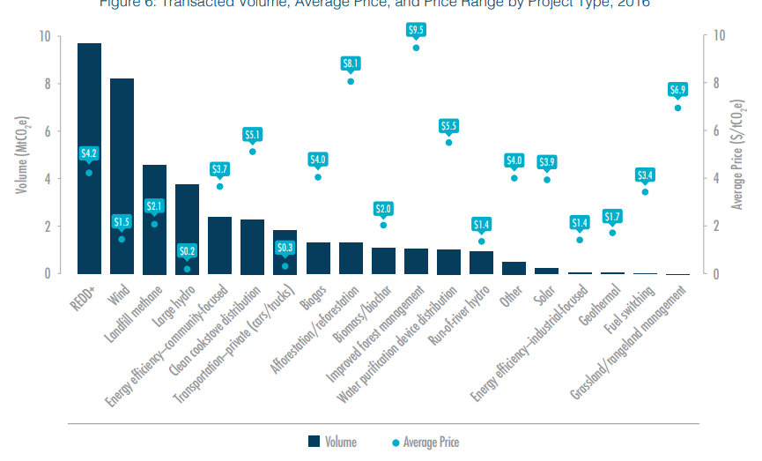

The afforestation/reforestation credits from Africa were transacted at an average of USD 6.7/tCO2e17 (ETB 202/tCO2e).

The average offset price also varies greatly due to use of different standards. The average price of offsets associated with the most common standards has been given below:

Table 7: Credit price across standards

|  |  |  |  |
| --- | --- | --- | --- |
| **Standard** | **Offsets Transacted**  **(%)** | **Average Price**  **(USD/ tCO2e)** | **Average Price**  **(ETB/ tCO2e)** |
| Verified Carbon Standard (VCS) | 58 | 2.3 | 69 |
| Gold Standard (GS) | 17 | 4.6 | 139 |
| Clean Development Mechanism (CDM) | 8 | 1.6 | 48 |
| Climate Action Reserve (CAR) | 8 | 3 | 91 |
| American Carbon Registry (ACR) | 3 | 4.7 | 142 |
| ISO 14064 | 4 | 0.4 | 12 |

The price of ECCs in the Ethiopian voluntary market will differ based on the project type, emission reduction potential and verification standard used. The price will have to be determined by the project developers for each project based on several factors which are:

* Project costs (which can differ based on the project’s location and type of activity) will include the project capital expenditure along with expenditure on operation and maintenance.
* Verification costs (likely to be change depending on the standard used, for example, verification using gold standard will lead to a higher verification cost than VCS, which will ultimately reflect in the credit price)
* Buyer’s preferences (specific location, project type, co-benefits, or other buyer criteria)
* Type of transaction (typically, offsets bought in bulk tend to sell at lower prices than offsets bought in smaller quantities)

To support the growth of the market, a floor price could be set up for the three types of projects considering the above-mentioned criteria. The floor price shall be determined keeping in view the basic minimum requirements for ensuring the viability of the projects and recovery of expenses incurred in the verification process. Currently, the minimum expenditure the project developers are likely to incur is the issuance fee which is estimated to be 0.1 USD/tCO2e (3 ETB/tCO2e) apart from other project costs.

Furthermore, inorder to ensure that buyers are incentivized to purchase credits, expenses incurred due to the purchase of credits should be deemed non-taxable. This will be in line with current taxation regulations in the country wherein expenses that are deducted for tax purposes are only those which were incurred in driving the organisation’s revenue, which is not the case with the purchase of ECCs.

At the same time, the ECC price, at the inception stage, is unlikely to go beyond the average carbon prices currently witnessed in mature carbon markets such as the EU ETS (currently stands at USD 27 (ETB 815) as on 22nd November 2019[19]) and the maximum credit price witnessed in the global voluntary carbon markets.

Therefore, the ECC pricing is likely to range between **0.1 to 50 USD/tCO2e (3 to 1500 ETB/** **tCO2e).**

# Annexure I: African Case Studies

**Case I: Nigeria — Municipal Solid Waste (MSW) Composting Project**

EarthCare Nigeria Limited (ENL) in collaboration with EarthCare Technologies Inc (ECTI) has developed a composting facility in Lagos, Nigeria. With a total project cost worth US$7.12 million, a waste disposal facility was established to produce compost for its use in Nigerian farms[20].

The project was registered under the CDM in 2010 and is expected to close on 31 December 2019. It generated about 30,000 carbon credits by the end of 2015.

The first Emissions Reduction Purchase Agreement (ERPA) was signed with the Carbon Fund for Europe (CFE) in June 2010 for 236,646 Certified Emission Reductions (CERs), which were generated during the period 2010-13.

This project, however faces a few challenges. The relative pricing of compost as against chemical fertilizers is high in Nigeria, owing to government subsidy on chemical fertilizers (a bag of compost costs US$17.50 compared to US$13.5 for a bag of chemical fertilizer)[21].

Another challenge pertains to the information gap that exists between the producer (ENL) and consumers of compost (farmers) regarding environmental impacts and benefits of compost versus chemical fertilizers.

**Case II: Ethiopia — Humbo assisted natural regeneration project**

The Humbo project is Africa’s first carbon trading forestry project that was registered under the Clean Development Mechanism (CDM). It has helped in restoring 2,700 hectares of previously degraded soil and also improved crop yields.

The project generated about 73,000 credits issued under the CDM, which were purchased by the World Bank’s BioCarbon Fund. The revenue generated from credits was reinvested in productive and community-driven activities and for paying for micro businesses such as beekeeping, livestock husbandry and for the construction of a flour mill and grain storage facility.

Among the key challenges, there was lack of awareness about the project within the community. The distribution of revenue among various cooperative societies was another challenge.

The communities also waited for almost four years for payments from the inception of the project to actually receiving the payments.[22]

**Case III: Morocco — Municipal Solid Waste Management Program**

The Morocco Landfills’ Gas Capture, Flaring and Use Program aims to reduce methane emissions from new and rehabilitated landfills by capturing biogas produced from solid waste.

The Fonds d’Equipement Communal, Morocco’s municipal development bank, develops and manages the activities of the project. The municipalities are responsible for implementing the project activities or for giving the contract to a private player. Through this project, about 1 million carbon credits are likely to be generated by the end of 2020, which in turn would be sold to the World Bank’s Carbon Partnership Facility (CPF).

The project is expected to not only contribute to mitigating greenhouse gas emissions, but also benefit the local environment by improving air quality and making the region more livable[23]

**Case IV: Madagascar — Ankeniheny-Zahamena Corridor Biodiversity Conservation (REDD+) Project**

Started in 2007, the Ankeniheny–Zahamena Corridor Biodiversity Conservation project aims to reduce deforestation and forest degradation of primary Malagasy forests through the creation of a 371,000 hectare protected area.

The project is being managed by Madagascar’s Ministry of the Environment, Ecology, Sea, and Forests with technical support from the World Bank’s BioCarbon Fund and Conservation International.

As of April 2015, the project generated about 3,915,496 carbon credits. The income generated from carbon credits offers an incentive to communities to protect forest areas.

Therefore, there is a huge potential for generating more credits from projects in various sectors that would further facilitate carbon trading in Africa. An establishment of a local carbon market, which is better suited to the African environment can encourage local investment in African projects and as a result increase trading volumes.[24]

# Annexure II: Global Case Studies

**Case I: Sri Lanka — Sri Lanka Carbon Crediting Scheme**

Under the Ministry of Mahaweli Development & Environment, the Sri Lanka Climate Fund provides services that include Sri Lanka Carbon Crediting Scheme (SLCCS), GHG Verification, and Project and Fund Management. SLCCS in particular, is a national voluntary carbon offset scheme that was launched in 2016. Through this scheme, Sri Lanka Certified Emission Reductions (SCERs) are issued to the domestic low carbon projects for trading in the domestic market.

The projects that meet SLCCS’s eligibility criteria are registered and are issued credits that can be sold and traded in the domestic market. The scheme supports voluntary emission reductions that help Sri Lanka-based companies to achieve their carbon neutrality goals. The table below describes how credits are expected to be measured, registered and issued under SLCCS.

A potential player (from both the public and private sector) can register for a GHG reduction project under the SLCCS through a process that is explained below:

CMA submission: The first stage requires a client to submit a carbon management assessment (CMA) to the SLCF for issuance of credits. It comprises the objective and methodology for a GHG emission reduction project submitted by the Project Developer (PD).

Validation: This stage includes site visits by the SLCF or other accredited auditor to evaluate whether the project meets the offset program requirements and standards.

Project registration: The successful validation will result in project registration, which is carried out by the Executive Board. Before the project gets registered, the board might request for corrective actions from the PD and resubmission of the report if there are discrepancies in the Validation stage.

Verification: The verification stage is carried out by a third-party auditor at regular intervals after project implementation, as specified by the protocol and project type.

Credit Issuance: At this stage, the Certified Emission Reductions (CER) are issued in the name of the client/project developer which are then used for trading.

Governance structure and key design features

The SLCF is established by an Executive Board (EB) for SLCCS that comprises three independent experts and two representatives of key government bodies. The existing institutions for key bodies that support the SLCCS are provided in the table below:

**Table 1: Institutional structure of Sri Lanka Carbon Crediting Scheme**

|  |  |  |
| --- | --- | --- |
| **Role** | **SLCCS institution** | **Key responsibilities** |
| Executive Body (EB) | SLCCS EB | * Strategic governance and guidance * Approving new methodologies and significant revisions * Approving project registrations * Approving credit issuance * Accrediting additional auditors (i.e. other than SLCF) although there is no process in place for this. |
| Administrator | SLCF | * Updating program rules and procedures * Reviewing project submissions and verification reports * Approving, overseeing, and auditing verifications * Maintaining the offset registry system |
| Advisory Boards | Currently the SLCCS EB plays this role, without any standing advisory committee | * Developing technical guidelines and rules for topics such as, forestry, standardization, accreditation of auditors, however, this has not been required so far under the SLCCS and at present, there is no specific body in place |
| Third-Party Auditors | Currently SLCF does validation and verification, but other entities could also be accredited | * Validating project applications * Verifying project performance and reported emission reductions |

**Table 2: Stages of the SLCCS project cycle**

| **Stage** | **Body** | **Description** |
| --- | --- | --- |
| ***Project registration/ listing*** | | |
| Select methodology | Project developer | The project developer selects a crediting methodology, which could be a SLCCS methodology or an internationally recognized methodology, such as those under the CDM or Verified Carbon Standard (VCS).  Once the project developer submits a registration request to the SLCCS, the project gets listed in SLCCS’s project pipeline. Further, the project developer is required to complete the Carbon Management Assessment (CMA) in the prescribed SLCCS’ format. |
| Validation | SLCF or another accredited auditor | The detailed assessment of the proposed offset project is carried out by a third party validation/verification body to evaluate if the project meets the offset program requirements and standards.  The validation stage includes an evaluation of baseline determination, additionality testing and monitoring plans. After this, a detailed review is conducted to ensure that the project application, including validation report (where relevant), is complete and consistent with program rules. It also ensures that all the legal requirements are fulfilled. |
| Project Registration | SLCCS EB | Once the project is validated, the accredited validation and verification body submits the CMA and Validation Report, which includes details on the estimated emission reduction or removal to the SLCCS’s Executive Body.  The project information is then listed on the SLCCS’s webpage and soon after which the project gets registered. |
| ***Project Verification and Issuance*** | | |
| Monitoring | Project Developer | In this stage, the project developer monitors and measure the GHG emission reduction or removals.  The information for a given monitoring period is documented in a monitoring report, using the SLCCS template.  The monitoring report is further validated and verified by the relevant accredited body. |
| Verification | SLCF or another accredited auditor | The verification is conducted by a third-party auditor at regular intervals after the project implementation, as specified by the protocol and project type. |
| SCER/SCER+ Issuance | SLCCS EB | Once the project is verified, the accredited validation and verification body submits the monitoring report and verification report to the SLCCS EB, which includes information on the verified GHG emission reduction or removal.  On receiving final approval from the SLCCS EB, the credits are issued either for Sri Lankan Certified Reductions (SCER) or SCER+.  SCERs are used for internal offsetting within an organization, while SCER+ units can be transferred through SLCCS’s registry to other entities that may wish to offset their GHG emissions. |

Under this scheme, the projects registered in the country include Kirkoswald Small Scale Hydropower SLCS Project, Dilmah (Ceylon Tea Services) Small Scale Hydropower Bundle Project, and Bogawanthalawa Small Scale Hydropower Project[25].

**Case II: China — Panda Standard**

In November 2009, the State Council of the People's Republic of China announced that the country aims to voluntarily reduce its carbon intensity to 40‒45 percent per unit of gross domestic product by 2020, compared to 2005 levels. To achieve this target, ***China Beijing Environment Exchange (CBEEX) launched the ‘Panda Standard V1.0’ in December 2009***, which is ***China’s first domestic voluntary emission reduction (VER) standard*** that issues voluntary credits. The Standard was jointly launched by four players — the China Beijing Environment Exchange and BlueNext as initiators and the China Forestry Exchange (CFEX) and US-based Winrock International as the co-initiators.

The standard's core structure is based on the international standard for GHG management activities that are developed by the International Organization for Standardization, in particular, ISO14064-2 Specification with guidance at the project level for quantification, monitoring and reporting of GHG emission reductions or removal enhancements, and ISO14064-3 Specification with guidance for the validation and verification of GHG assertions[26].

Additionally, CBEEX provides membership services for professionals such as brokers and buyers. The type of projects that are submitted under the Standard primarily include Agriculture, Forestry and Other Land Use (AFOLU), transportation and construction.

In August 2009, CBEEX announced the accomplishment of the first VER trade in China — Tianping Auto Insurance Company Ltd. purchased carbon credits (worth RMB277,000 for 8,026 tons of carbon emission reduction credits), generated from a green travel activity, known as Beijing Green Commuting Initiative during the 2008 Olympics, to offset the carbon emissions generated during its first five years of operation from 2004‒08. The demand for credits is driven by competition among domestic and international businesses that engage in corporate social responsibility and position themselves as green and environmentally conscious firms.

In March 2011, China-based Franshion Properties (China) Limited purchased 16,800 tons of VERs from CBEEX[27]. Furthermore, in June 2011 CBEEX released the list that ranked China-based enterprises by the amount of voluntary emission reduction of GHG.

The broad institutional structure of the ‘Panda Standard’ is described below:

**Figure (3): Structure of Panda Standard**

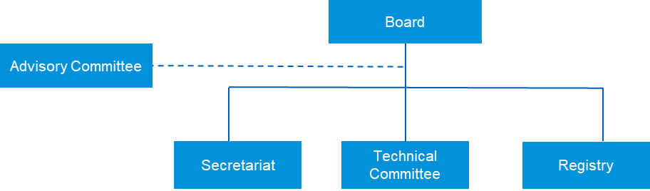

*Source: International Carbon Action Partnership (ICAP)*

* *Panda Standard Board: I*t is the executive body of the Panda Standard Association that is responsible for making and driving its strategy. The Board comprises the founders and co-founders of the Panda Standard and external representatives such as national authorities, international organizations, non-governmental organizations, and research institutions.
* *Panda Standard Secretariat*: It is the administrative body of the Panda Standard Association, which is responsible for various administrative tasks that are required throughout the project lifecycle. It links the Board, the Technical Committee, the Registry, and the project proponents.
* *Panda Standard Technical Committee*: The committee comprises internal and external experts, both international and domestic. These experts are responsible for approving project registration, new methodologies, and tools or procedures that a project proponent submits to the Secretariat.
* *Panda Advisory Committee*: It is the consultative body of the Panda Standard Association. It is a pool of external experts, both international and domestic from various organizations involved in carbon markets.  
  The committee is responsible for reviewing the periodic revisions to the document submitted, sectoral specifications and any publications of the Panda Standard Association that are issued to project proponents.
* *Panda registry*: The registry is responsible for issuance of credits to the project developers, once the approval for credit issuance has been received from various committees and Secretariat under the Panda Board.

**Project approval process:**

The process for approval of a project involves approval of baseline and monitoring methodology and of tools and other procedures that are defined by a project proponent in the project description document. The review process involves a review from Panda’s Technical Committee and key sectoral stakeholders/experts that provide their comments on the document submitted.

**Figure (4): New methodology approval process**

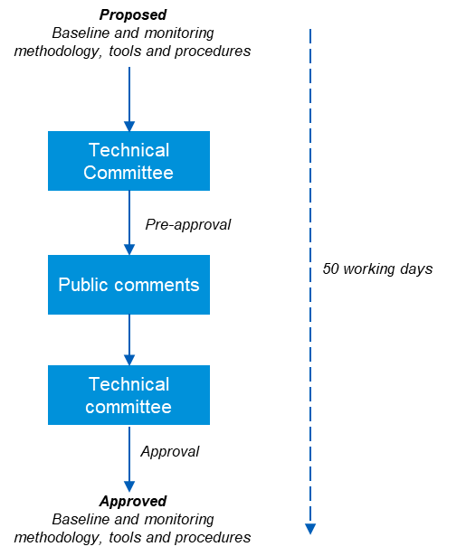

*Source: International Carbon Action Partnership (ICAP)*

**Project life cycle:**

The project cycle involves a three stage system — Verification (within third parties), Registration (National registry institutions) and Trade (within exchanges)

**Figure (5): Panda Standard project life cycle**

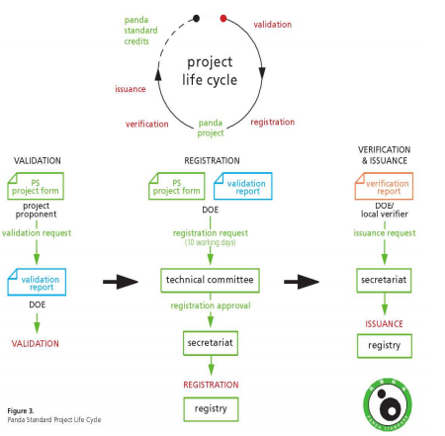

*Source: International Carbon Action Partnership (ICAP)*

* *Validation and Registration*: The validation is performed by an independent Third Party Auditor, who on approval, requests for registration of the project to the Secretariat. At this stage, atleast one on-site visit by a Third Party Auditor is carried out for validation and for each verification[28].
* *Monitoring, Verification and Certification*: The verification must be performed by an independent Third Party Auditor that subsequently requests for the issuance of credits by the Secretariat, based on the verified GHG emissions reduced or removed by the project activity. The verification of the registered Panda Standard projects must be performed at least every five years, and at any application for renewal of a project’s crediting period.[29],[30], [31]

**Key players and their roles:**

**China Beijing Environment Exchange:** It is a market platform, authorized by the Beijing Municipal Government, for trading various environmental equities. It has an advanced transaction system and extensive network of membership and partnership. The exchange is a corporative institution for open and centralized transactions of environment equities, which was launched by China Beijing Equity Exchange (CBEX), the New Energy Investment Ltd. of China National Offshore Oil Corp., China Guodian Corp., and China Everbright Investment Management Corp.

***BlueNext***: A France-based environmental equity market, which is jointly founded by the global exchange group NYSE Euronext and the French government-controlled bank, Caisse des Depots. It is among the transaction markets of carbon dioxide emissions, accounting for 93 percent of the market shares.

***China Forestry Exchange (CFEX)***: It is a state-owned company that was established in 2009 with the approval of the State Council, State Forestry Administration and Beijing Municipal Government. It is a trading exchange for forestry rights and assets established to maximize the value of domestic forestland by attracting domestic and international capital.

**Winrock International**: Winrock International is a US based entity that runs the American Carbon Registry (ACR), a voluntary offset program in the US for carbon offset issuance and transparent on-line transaction reporting. With this cooperation, ACR has issued about 30 million project-based carbon offsets[32].

**Case III: New Zealand — The Registry Company (Regi) to APX carbon registry**

The Marketplace Company (M-co) operated online voluntary carbon offset registry known as the ‘Regi’ registry, which was tailored to suit New Zealand’s voluntary carbon market. The registry was hosted by the Registry Company and was developed to assess the demand in New Zealand’s voluntary carbon market. While the website was designed for players in New Zealand’s voluntary carbon market, it also considered foreign account requests on a case-by-case basis[33]. The registry was highly transparent as it listed information about the certification, offset providers, project names, transaction status, and credit types and volume, which was accessible by the general public.[34]

Through this registry, the Gold Standard[35] credits were issued on a provisional basis. Furthermore, with the establishment of the Gold Standard Registry by the Gold Standard Foundation, the information from Regi registry was transferred to a carbon registry platform, known as the APX VCS registry. This platform is being offered by US-based APX Inc., a provider of web-based platform and account management tool for the registration, tracking, and retirement of GHG offsets.

The APX VCS registry is a platform for issuing, tracking and retiring Verified Carbon Units (VCUs) and is based on the rules governed by the Verified Carbon Standard Association[36] for issuance of VCUs. Each VCU represents one ton of emission reductions from a specific project that has been validated and verified according to the VCS Program rules.

The potential proponent who wishes to list themselves on the VCS registry for selling their credits and corporations, governments and individuals, who seek to offset their GHG emissions need to first open an account online. The steps involved in opening an account are explained below:

* *Step 1*: The potential project proponent needs to go through the APX VCS documents that are available online. These include VCS User Guide, Terms of Use, Operating Procedure, Declaration of Agency[37] and regulated person attestation[38].
* *Step 2*: The appropriate account type needs to be selected for initializing the registration. The types of accounts available are Project Proponent Account[39], General Account Holder[40], Retail Aggregator Account Holder[41], and End-User Account Holder[42].
* *Step 3*: The APX VCS Registry Administrator reviews the account application and provides approval if the application is complete.
* *Step 4*: The General, Retail Aggregator and End User Accounts are billed for the Annual Account Subscription Fees once account approval is obtained. The fees have to be paid within 30 days once the invoices become available on the registry[43].

Project registration: This involves certain steps that are explained below:

* *Step 1:*If the project is new and awaiting Validation,the proponent can list itself on the VCS Project Pipeline. For doing this, the project needs to be registered in the APX VCS registry account for review. The proponent needs to upload the required documents, including the project description document that comprises details on sectoral scope, project type, project location, baseline scenario, and data and parameters monitored etc.

For instance, a project proponent known as the Horn of Africa Regional Environment Center and Network, listed its project ‘East African Afforestation, Reforestation and Revegetation Program’ (EARRP) on the VCS Project Pipeline (that is estimated to reduce an emission reduction equaling 567,227 tCO2e during 2014‒44)[44]. While the current status for this project on the VCS project database is under development, its listing on the project pipeline provides confidence to potential investors and buyers that the project meets VCS Standard.[45]

* *Step 2*: If the project has undergone validation, the project proponent is required to submit the required documents for review by the APX. Once the review is completed, the approval for the project is provided with a project status as Validated.
* *Step 3*: If the project has undergone Validation and Verification, the required documents are uploaded and issuance request for Verified Carbon Units (VCU) is created followed by the submission of the project for review by the APX. After the review is completed and no further clarifications are required, the project is approved and issued a “Verified” status. It also involves invoices that are raised by APX for the requested VCUs. Once the payment is made by the proponent, the VCUs are deposited in its account. After this, the proponent is able to initiate the transfer of VCUs to the buyers.
* *Step 4*: If the project is seeking issuance for a subsequent verification period, a potential proponent needs to update the required documents on the APX VCS registry, update details about the project, create issuance requests and submit the project for review by APX. After the review process, the invoices for VCUs are issued. Once the payment is received by the proponent, the VCUs are deposited in its account[46].

**Table 3: Details about project proponents in Africa that are registered under the APX VCS registry32**

| Project name | Project proponent | Country | Sector | Estimated annual emission reductions (tCO2e) | Project status |
| --- | --- | --- | --- | --- | --- |
| East African Afforestation, Reforestation and Revegetation Program | Horn of Africa Regional Environment Center and Network | Ethiopia | Agriculture, Forestry, Land use | 18,907 | Under Development |
| Northern Kenya Grasslands Project | Northern Rangelands Trust | Kenya | Agriculture, Forestry, Land Use | 1,797,493 | Under Validation |
| Improved Jikos Project in Kenya | ClimateCare Limited | Kenya | Energy demand | 40,064 | Under Validation |
| Luangwa Community Forests Project | BioCarbon Partners | Zambia | Agriculture, Forestry, Land Use | 1,251,896 | Under Development |
| Gilé National Reserve REDD Project | National Mozambican Public Agency for Parks and Reserves Conservation (ANAC) | Mozambique | Agriculture, Forestry, Land Use | 68,821 | Under Validation |
| Ejuva One and Ejuva Two Solar Projects | AERA Group | Namibia | Energy (renewable/non-renewable) | 26,746 | Under Development |

Source: VCS project database

# Annexure III: Sectoral GHG Accounting Methodologies

### Measuring GHG Emission Reductions from Composting Activities

The measurement of GHG emission reduction from composting activities shall be performed using the methodology developed under the COMPOST NAMA Programme. The same shall be uploaded on the registry for reference. The details of the methodology have been detailed below:

* The methodology for measurement of GHG emissions has been developed from the following CDM methodologies:
  + CDM Small-scale methodology AMS-III.F. Avoidance of methane emissions through composting, version 12.0
  + CDM methodological tool 03 - Tool to calculate project or leakage CO2 emissions from fossil fuel combustion, version 03.0
  + CDM methodological tool 04 – Emissions from solid waste disposal sites, version 08.0
  + CDM methodological tool 05, - Baseline, project and/or leakage emissions from electricity consumption and monitoring of electricity generation, version 03.0
  + CDM methodological tool 13 – Project and leakage emissions from composting, version 02.0
* A calculation tool has also been developed for calculation of emissions from mitigation actions and leakage emissions along with achieved emission reductions. The snapshot of the tool has been provided below.

Figure 15: Snapshot of Composting MRV Tool

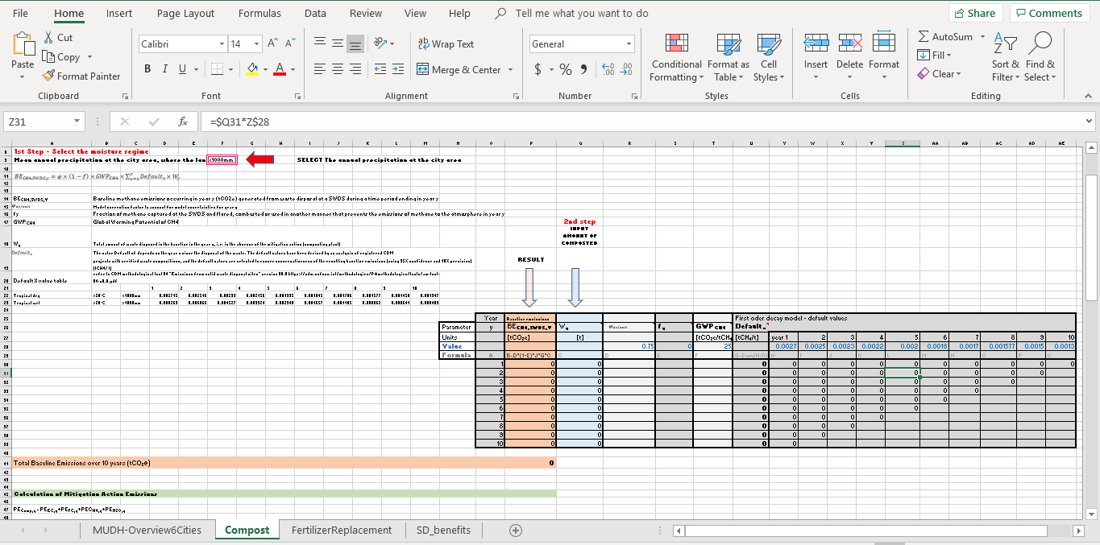

* With regards to measuring sustainable development benefits, the framework details methodologies for two indicators, which are saved landfill space and jobs created due to composting.

### Measuring GHG Emission Reductions from Fertilizer Replacement

The measurement for fertilizer replacement will be done using the measurement data for compost production and using the same tool as detailed in the previous section.

### Measuring GHG Emission Reductions from Urban and Peri-urban Reforestation of Degraded Land

The measurement of the emission reduction through change of degraded land to forest land will be done using the FAO Ex-Ante Carbon-balance Tool (Ex-Act). The system boundary encompasses the urban and peri-urban boundary of the city. In order to measure the emission reductions using the tool, the following data will have to be recorded:

* Activity Data: Area of land (ha)
  + Clearly define the boundary of each degraded land area, within the system boundary, which will be dedicated for reforestation as mitigation action. Use maps or satellite images, including GIS data, that each degraded land area can be verified by external parties.
  + Assign a unique identification code or name for each degraded land area to avoid confusion.
  + Calculate the plot size for each degraded land area. Exclude the degraded land areas which are less than 0.5 ha. Areas less than 0.5 ha are not qualified as “forest” according to the national definition.
* Documented evidence that the area has been classified as degraded land.
* Initial land use according to regional/land categories and/or IPCC categories.
* Information on climate zone, moisture regime and soil type.
* Details on the type of vegetation that will be planted.
* Use of fire for land conversion to burn dead biomass.

For measuring sustainable development benefits, the framework lists the following indicators:

* Supporting and enhancing biodiversity
* Providing opportunities for open-access outdoor recreation
* Enhancing the visual quality of the landscape
* Improving air quality
* Strengthening climate resilience

### Measuring GHG Emission Reductions from Other Sectors

The measurement of the emission reductions through mitigation projects implemented in other sectors as defined under the sectoral scope in section 2.2 should be conducted using the CDM methodologies available at <https://cdm.unfccc.int/methodologies/index.html>.

1. Cap and trade is a common term for a government regulatory program designed to limit, or cap, the total level of emissions of certain chemicals, particularly carbon dioxide, as a result of industrial activity
2. [What are carbon markets?, ODI website, accessed on 26 April 2019](https://www.odi.org/sites/odi.org.uk/files/odi-assets/publications-opinion-files/6088.pdf)
3. [Voluntary Carbon Market Insights: 2018 Outlook and First Quarter Trends, Forest Trends website, August 2018, accessed on 25 April 2019](https://www.forest-trends.org/wp-content/uploads/2018/09/VCM-Q1-Report_Full-Version-2.pdf)
4. [Carbon Markets: Have They Worked for Africa?, Integrated Business and Economics website Journal, April 2017, accessed on 17 July 2019](https://www.sibresearch.org/uploads/3/4/0/9/34097180/riber6-2_06m16-013_90-104.pdf)
5. [Carbon markets: Have they worked for Africa, Review of Integrative Business and Economics Research, accessed on 18 July 2019](https://www.sibresearch.org/uploads/3/4/0/9/34097180/riber6-2_06m16-013_90-104.pdf)
6. Voluntary carbon market, 2018, accessed on 19 July 2019
7. [Overview of Carbon Offset Programs, World Bank, accessed on 31 May 2019](http://documents.worldbank.org/curated/en/891711468309365201/pdf/939450WP0201500ers0385391B00PUBLIC0.pdf)
8. As an approved Offset Project Registry under the CA ETS, CAR can issue offsets for certain project types under ARB Compliance Offset Protocols. These offsets then have to be transitioned into ARB Offset Credits to be used for compliance under CA ETS.
9. [Germany’s carbon market cooperation with Ethiopia: Prospects for engaging with Article 6 of the Paris Agreement, October 2017, accessed on 18 July 2019](https://newclimate.org/wp-content/uploads/2017/11/case_study_ethiopia.pdf)
10. [The Institutional Strengthening for the Forest Sector Development Program in Ethiopia, MoFED website, accessed on 19 July 2019](http://www.mofed.gov.et/documents/10182/32227/Forest+sector+development_2017_18+annual+report.pdf/7cada85e-b360-490c-8b54-8ac7fb17140f)
11. [Institutional Strengthening for Forest Sector Development in Ethiopia, UNDP website, accessed on 19 July 2019](https://www.et.undp.org/content/ethiopia/en/home/operations/projects/climateriskandresilience/project_institutionalstrengtheningfoforestsectordevinethiopia.html)
12. [Ethiopia Country Planning Framework 2016-2020, GGGI website, accessed on 19 July 2019](https://gggi.org/site/assets/uploads/2017/12/GGGI-Ethiopia-Country-Planning-Framework-2016-2020.pdf)
13. [The Federal Democratic Republic of Ethiopia, March 2017, MoFED website, accessed on 19 July 2019](http://www.mofed.gov.et/documents/10182/32227/FTI+Final+report.pdf/f2a43bdb-c94a-4ff6-957f-a6725d689786)
14. [United Nations Development Programme, GEF website, accessed on 19 July 2019](https://www.thegef.org/sites/default/files/project_documents/PIMS_-_5541_-_CCM_-_Ethiopia_-_COMPOST_-_ProDoc_-_final_-_13_July_2016_-_final.pdf)
15. Corrective Actions are actions to be taken in case there are errors and/or non-conformities in the calculations submitted as part of the monitoring report to the verifier at the time of verification
16. Clarifications Requests are requests raised by verifier in case any information provided by the project developer is inadequate or unclear.
17. State of Voluntary Carbon Market, 2017 [Accessed at: <https://www.forest-trends.org/wp-content/uploads/2017/07/doc_5591.pdf>, Accessed on: 31st May 2019]
18. Voluntary Carbon Markets Insights: 2018 Outlook and First-Quarter Trends, 2018 [Accessed at: <https://www.forest-trends.org/wp-content/uploads/2018/09/VCM-Q1-Report_Full-Version-2.pdf>, Accessed on: 31st May 2019]
19. Markets Insider [Accessed at: <https://markets.businessinsider.com/commodities/co2-emissionsrechte>, Accessed on: 28th May 2019]
20. Nigeria – Municipal Solid Waste Composting Project, UNFCCC website, accessed on 22 May 2019
21. [Assessment of the Regenerative Potential of Organic Waste Streams in Lagos Mega-City, Arizona State University, May 2016, accessed on 3 May 2019](https://repository.asu.edu/attachments/170613/content/Opejin_asu_0010N_15920.pdf)
22. [Ethiopia Climate Project Receives Africa’s First Forestry Carbon Credits under the CDM, 9 October 2012, The World Bank, accessed on 31 May 2019](http://www.worldbank.org/en/news/feature/2012/10/09/ethiopia-climate-project-receives-africa-s-first-forestry-carbon-credits)
23. [Generating carbon credits from landfills in Morocco, The World Bank, October 2015, accessed on 29 April 2019](http://projects-beta.worldbank.org/en/results/2015/10/13/generating-carbon-credits-morocco)
24. [Carbon Markets: Have They Worked for Africa?, Integrative Business and Economics Research, April 2017, accessed on 30 April 2019](https://sibresearch.org/uploads/3/4/0/9/34097180/riber6-2_06m16-013_90-104.pdf)
25. [Market Readiness Proposal to the partnership for Market Readiness, PMR website, December 2017, accessed on 30 April 2019](https://www.thepmr.org/system/files/documents/Sri%20Lanka%20Market%20Readiness%20Proposal_updated_final.pdf)
26. [China: The First Chinese Standard for Voluntary Greenhouse Gas Offset, Mondaq website, February 2010, accessed on 7 May 2019](http://www.mondaq.com/china/x/93854/Environmental+Law/The+First+Chinese+Standard+for+Voluntary+Greenhouse+Gas+Offset)
27. [Green low-carbon development in China, Google books, accessed on 7 May 2019](https://books.google.co.in/books?id=uC7ABAAAQBAJ&pg=PA164&lpg=PA164&dq=VER+with+tianping+insurance+on+panda+exchange&source=bl&ots=SX03Ilf69G&sig=ACfU3U2PZCHibMQHctv0AFh48PSBjlOg7Q&hl=en&sa=X&ved=2ahUKEwjDobj32ojiAhVBT98KHfJ0DUsQ6AEwA3oECAcQAQ#v=onepage&q=VER%20with%20tianping%20insurance%20on%20panda%20exchange&f=false)
28. [China, PMR website; accessed on 6 May 2019](https://www.thepmr.org/country/china-0#All%20Documents%20&%20Presentations)
29. [Overview of Carbon Offset Programs, January 2015, World Bank website, accessed on 6 May 2019](http://documents.worldbank.org/curated/en/891711468309365201/pdf/939450WP0201500ers0385391B00PUBLIC0.pdf)
30. [Panda Standard, CORE website, accessed on 6 May 2019](https://www.co2offsetresearch.org/policy/PandaStandard.html#Eligibility)
31. [Panda Standard: AFOLU & Ecological Poverty Alleviation, China Beijing Environment Exchange, accessed on 8 May 2019](https://icapcarbonaction.com/en/?option=com_attach&task=download&id=72)
32. [China Beijing Environment Exchange (CBEEX) Launches Panda Standard at UN Climate Change Conference in Copenhagen, CBEX website, accessed on 7 May 2019](http://www.cbex.cn/article/PressRelease/201002/20100200000185.shtml)
33. [M-Co sets up carbon trading registry, Stuff Limited website, 31 January 2009, accessed on 7 May 2019](http://www.stuff.co.nz/business/50278/M-Co-sets-up-carbon-trading-registry)
34. [Carbon Project Registry Systems and International Carbon Market Regulations, UNDP website, January 2010, accessed on 7 May 2019](https://www.undp.org/content/dam/turkey/docs/news-from-new-horizons/issue-50/UNDP-TR-Ankara-1-Carbon-Registry-and-Int-Regs.pdf)
35. The Gold Standard, or Gold Standard for the Global Goals, is a standard and logo certification mark program for non-governmental emission reductions projects in the Clean Development Mechanism (CDM), the Voluntary Carbon Market and other climate and development interventions
36. The rules include project registration process, the methodology approval process, the accreditation requirements for validation/verification bodies, and the functioning of the VCS registry system.
37. This is optional and it is required if the potential player intends to have another organization manage your account.
38. This is optional and required if the potential player intends to hold credits on behalf of third parties.
39. Project proponent account is the account type that has been assigned the Rights of Registration for a given offset project. This gives the designated Account Holder full and sole management and authority over the transactions and activities related to the offset project within the APX VCS Registry. This account can transfer VCUs to counterparties. <http://apx.com/wp-content/uploads/2018/01/VCS-User-Guide.pdf>
40. General account holders can register projects and transfer and retire VCUs.
41. This account receives VCUs in its account and retire on behalf of third parties
42. This account receives VCUs in its account and retire VCUs for its own benefit
43. [Open an account, APX website, accessed on 8 May 2019](https://apx.com/registries/apx-vcs-registry/open-an-account/)
44. [Draft project description, Pipeline documents, Verra VCS project database, accessed on 8 May 2019](https://www.vcsprojectdatabase.org/#/pipeline_details/PL1443)
45. [Project database, Verra VCS website, accessed on 8 May 2019](https://www.vcsprojectdatabase.org/#/pipeline)
46. [Register a project, APX website, accessed on 8 May 2019](https://apx.com/registries/apx-vcs-registry/register-a-project/)